

Subscriptions

# Introduction

## Banking institutions are one of the largest in the world. They complete millions of transactions daily in person, digitally, and over the phone. Some of these transactions are efforts at engaging their customers in campaigns to sell additional banking products and offerings. Currently banking institutions are executing their best efforts to engage some of the youngest generations that are aging into the top salary brackets. The majority of their funding is going into digitizing their banking features. Additionally, [Everfi](https://everfi.com/insights/blog/retail-bank-marketing-trends/) has found that putting more resources into data is one of the continuing trends for banks today. While putting funds towards data in marketing for banks is important, so is the ability to properly analyze the data and predict desired outcomes based on a bank’s customer’s unique traits. The following paper works to achieve just this.

## Our chosen data set is from a Portuguese banking institution and is referencing a campaign that is trying to achieve a subscription (yes or no outcome) of a banking deposit by their customers. In this report we analyze the given data set variables via an exploratory data analysis, simple logistic regression model, and complex logistic regression models to determine the best variables to predict the subscription outcome.

# Data description

## The data we utilized for this analysis was provided by the UCI Machine Learning group which can be found [here.](https://archive.ics.uci.edu/ml/datasets/Bank%20Marketing#) The data is related to the direct marketing campaigns of a Portuguese banking institution. These marketing campaigns were based on phone calls. On many occasions there was more than one contact to the client and it was required in order to determine if the product subscription (y - bank term deposit) would be a ‘yes’ or a ‘no’.

|  |  |
| --- | --- |
| **Variable Name** | **Variable Description** |
| age | age of customer |
| Job | type of job (categorical: 'admin.','blue-collar','entrepreneur','housemaid','management','retired','self-employed','services','student','technician','unemployed','unknown') |
| Martial | marital status (categorical: 'divorced','married','single','unknown'; note: 'divorced' means divorced or widowed) |
| Education | categorical: 'basic.4y','basic.6y','basic.9y','high.school','illiterate','professional.course','university.degree','unknown' |
| Default | has credit in default? (categorical: 'no','yes','unknown') |
| Housing | has housing loan? (categorical: 'no','yes','unknown') |
| Loan | has personal loan? (categorical: 'no','yes','unknown') |
| Contact | contact communication type (categorical: 'cellular','telephone') |
| Month | last contact month of year (categorical: 'jan', 'feb', 'mar', ..., 'nov', 'dec') |
| Day_of_Week | last contact day of the week (categorical: 'mon','tue','wed','thu','fri') |
| Duration | last contact duration, in seconds (numeric). Important note: this attribute highly affects the output target (e.g., if duration=0 then y='no'). Yet, the duration is not known before a call is performed. Also, after the end of the call y is obviously known. Thus, this input should only be included for benchmark purposes and should be discarded if the intention is to have a realistic predictive model. |
| Campaign | number of contacts performed during this campaign and for this client (numeric, includes last contact) |
| pdays | number of days that passed by after the client was last contacted from a previous campaign (numeric; 999 means client was not previously contacted) |
| previous | number of contacts performed before this campaign and for this client (numeric) |
| poutcome | outcome of the previous marketing campaign (categorical: 'failure','nonexistent','success') |
| emp.var.rate | employment variation rate - quarterly indicator (numeric) |
| cons.price.idx | consumer price index - monthly indicator (numeric) |
| cons.conf.idx | consumer confidence index - monthly indicator (numeric) |
| euribor3m | euribor 3 month rate - daily indicator (numeric) |
| nr.employed | number of employees - quarterly indicator (numeric) |
| y | Dependent Variable: Subscription completion (yes or no) |

# Exploratory data analysis (EDA)

## Upon first look we reviewed the raw data set we were given. We can see there is a full complement of both continuous and categorical variables independent variables with a single dependent variable - y [Figure 1]. Variable y is a dichotomous outcome of yes or no. It is referring to whether or not a bank customer signed up for a deposit subscription. In order to keep variable logically labeled, we changed the name of variable *y* to variable *Subscription*.

## The next step in our EDA consisted of dropping logically irrelevant variables. At first glance we did not feel comfortable eliminating any variables without further insight into if they may or maynot affect the dependent variable - y. That further investigation led us to realize that the *duration* variable is actually a measurement taken post call completion. As this would not be a variable unique to a specific customer pre marketing campaign phone call it would not be appropriate to use in predictive modeling. Therefore, we removed it from our list of viable variables [Figure 2].

## Our next round of investigation took us into looking for any missing values or NAs [Figure 3]. We used an R package called mice and were able to quickly determine that there was no need to complete any NA value extrapolation to move forward

## The continuous variable evaluation was our piece of the EDA. We accomplished this by creating individual boxplots of the continuous variables versus *Subscription*. When using this methodology you must examine the graph for large differences in the box-plot ranges. These boxplot graphs can be found in Figure 4 through Figure 14. An additional way to evaluate the important continuous variables is through density plots. When peaks are separated by different colors it is an indicator that the variable is a good one to determine the dependent variable - *Subscription*. Our function can be found in Figure 15 along with every density plot supplied by that function. Using both the boxplot and density plot methods there does seem to be some continuous variables that would be good for predicting, these include: *pdays, campaign, previous, cons.price.indx, cons.conf.idx, emp.var.rate, nr.employed*. Leaving us only with *age* to remove for now.

NOTE: We noticed that the *pdays* variable appears like customers fall into one of two groups: *a number* versus *999*. We think ideally this would be a categorical variable for better predicting. We address this in Objective 2: Complex Logistic Model.

## We have completed selecting those continuous variables that are significant for our evaluation. However, we need to now check on if these continuous variables contain any multicollinearity. In Figure 16 you can see we performed a large pairs plots with the separation of yes and no responses from our dependent variable *Subscription*. We can see some strong linearity showing between *nr.employed, euribor3m, emp.var.rate,* and *previous.* However, we are not observing any large separation between the yes and no categorical responses from *Subscription*; therefore, we will not move forward with a Principal Component Analysis (PCA) for our continuous variable reduction. We are however, going to take a closer look at the level of linearity correlation matrix. In Figure 17 you can see a large correlation matrix that gives us the correlation gradient from highly negatively correlated to highly positively correlated from dark orange to dark blue respectively. When reviewing this matrix it became clear that multicollinearity would be an issue if some of these continuous variables were not removed. We moved forward with removing the following variables: *pdays, euribor3m, nr.employed, emp.var.rate, age* [Figure 18]. A secondary correlation matrix showing little to no multicollinearity can be found in Figure 19.

## After our continuous variable response analysis we move forward to our categorical variable response analysis. In order to complete this we wrote a function that created a plot grid of all the bar graphs that were filled to percent of total for easy comparison across categories. However, the plot grid was difficult to read. So we moved forward with leveraging that function for the individual analysis of each categorical variable towards our dependent variable *Subscription*. This function can be found in Figure 20 and every corresponding graph for each categorical variable graphed against *Subscription* can be found in Figure 21. In these bar graphs we can see where the yes *Subscription* response differs greatly for certain categories, this is our indication that the particular categorical variable graphed should be leveraged for our model. After completion of reviewing these graphs individually we have determined there are a group of variables we can leave behind [Figure 22] and move forward with our final collection of variables.

## NOTE: When reviewing the categorical variables it stood out to us that many of them might benefit from slight manipulation and transformation in order to strengthen our model. However, this would make interpretation much more difficult. We address this in Objective 2: Complex Logistic Model by creating a secondary logistic model that is more with these altered variables. The actions we take for these manipulations will be outlined and is our secondary EDA for a logistic model completion.

## Our final step in our EDA process will be to do a quick statistical summary on our final selected variables to make sure that all variables look good to move forward with modeling. In Figure 23 we have completed this step and are ready to move forward with our simple logistic model for Objective 1.

# Objective 1: Simple logistic regression model

## Problem Statement and Approach Review

This analysis consists of a simple logistic approach in order to determine the best variables in the given data set to predict the subscription (y) variable outcome of yes or no. Through our EDA we were able to reduce the variable options as well as develop intimate knowledge of our independent variables. Therefore, we felt it more valuable to utilize our intuition to build our simple logistic model. Validation of results was accomplished by splitting the data into testing and training sets. The training set was partitioned such that it had an equal number of “yes” and “no” outcomes by splitting the “yes” outcomes in half and randomly selecting an approximately equal number of accompanying “no” responses; the rest of the data was left to the test set. These training and testing partitions were exported to csv files for use with other models in R as well for consistency.

## Model Selection

### Type of Selection

### The initial regression model was built using variables that distinguished themselves through the EDA. These runs were accomplished through PROC LOGISTIC in SAS. In the first run, two of those variables (education, previous) did not show statistical significance in the Type 3 Analysis of Effects and were removed [Figure 24].

### All remaining variables were significant in the successive run [Figure 25].

### Comparisons of the ROC Curves between the training set [Figure 26] and the test set [Figure 27] did not reveal any issues between the train and test sets such as overfitting. The Area under the curve for the two were similar.

### The Fit statistics for the model were scored on the test set to get a realistic idea of performance [Figure 28].

### This was important because the training set was made with an equal proportion of outcomes to prevent issues with running the models, but the test set was more representative of the original data where there were far more “no” responses than “yes”. [Figure 29] is a frequency table of the results on the test set predictions that shows an approximate sensitivity of 65% and specificity of 83%. These are based on the default prior probability of the model of .5.

### Note: We will further discuss in our Objective 2: Conclusion on the potential choices to make when tuning the prior probability.

### For model comparison, another model was built using LASSO in the PROC HPGENSELECT function to select variables from the entire set of original variables (main effects only). When the selected variables were re-run in PROC LOGISTIC and checked again for significance, the remaining variables were almost identical to those chosen through the EDA. The *job* variable was the only one excluded using LASSO; this is not a surprising consequence as this variable had the highest p value in the Type 3 analysis of effects of our initial model. An examination of the results showed no benefit to changing our initial model for the slight difference in variable selection so it was left as is.

### 

### Checking Assumptions

#### Lack of Fit Test

The Deviance and Pearson Goodness of Fit tests did not show any signs of poor fit [Figure 30]

#### Influential Point Analysis

[Figure] shows a leverage plot. While there appears to be an outlier, it does not have enough influence to cause any concern.

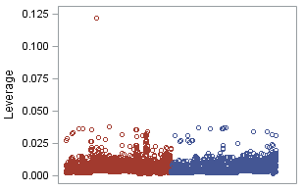.

## Parameter Interpretation

### Interpretation

The binary logistic regression parameter estimates (log odds ratios) for the model and their standard errors are shown in [Figure 31]. These are the coefficients used when the model predicting the log odds of a “yes” response is defined by the equation *log[p/(1-p)] = 𝛃0 + 𝛃1X1 + 𝛃2X2 + 𝛃3X3 … 𝛃nXn* where *p* is the probability of a “yes” response. Our model can be represented using the equation log[*pyes*/(1-*pyes*)] = -35.9 -.495\**Jobadmin* - .605\**Jobblue-collar* - .196\**Jobentrepreneur* - .743\**Jobhousemaid* - …*{see* *Figure 31**}* … - .520\**euribor3m* + .433\**cons_price_idx* + .047\**cons_conf_idx.*

### Confidence Intervals

Figure 32 displays the predictor variables in terms of odds ratios and their confidence intervals. These represent the exponentiation of the model parameter estimates. These estimates can be used to interpret the effect of a single unit change of any predictor on the odds ratio of obtaining a “yes”, given the other variables in the model are held constant. For example, a one unit increase in the consumer price index (*cons_price_idx*), the odds ratio for getting a “yes” response will increase by 1.54 (95% confidence interval of this change of [1.03,1.07]), holding all other predictors constant.

## Conclusion

XXXXXX

# Objective 2: Competing Models

## Model Selection

### Make sure it is clear how many models were created to compete against the one in Objective 1. Make note of any tuning parameters that were used and how you came up with them (knn and random forest).

* + 1. Train and test split data sets to be pulled from SAS and placed into data folder on Github for R model comparisons
       1. Complex Logistic Regression: added complexity: **Branum/Josh**
          1. Under sample (test and train sets from Josh)
          2. Adjusted metrics

pdays: changed to categorical 2 levels

Job: extricated Retiree and Student only for model

Education: illiterate v else

Default: Unknown & No v else

Month: binned Sep, Oct, March, Dec v else

poutcome: Success v else

NEW: Bin age?

NEW: New metrics that are combined?

* + - 1. Linear Discriminant Analysis (LDA)/Quadratic Discriminant Analysis (QDA)

During the EDA we surfaced very little separation from a simple 2 dimensional comparison view of the continuous variables. If you view Figure 16 you can see it appears that all the variables very randomly overlap without any sort of solid separation. In further investigating the ability to run an LDA/QDA on this data, we completed the same pairs plot on the only continuous variables left [Figure PairsPlot]. Again we don’t see any clear separation, instead we moved forward with forming an LDA and QDA using a 3 dimensional model from all 3 continuous variables we had after our completed EDA.

We leveraged the same test and train sets as the rest of the models in Objective 2. First, we created a three dimensional plot on our test set to see if there was any evident separation between the two results for the dependent variable, Subscription [3d Model]. When doing this we first made sure to remove all unwanted variables [Figure XX] and confirm the results count of yes and no results for subscription were equal in the train data set [Figure XX].

Once we had made sure the data was where it needed to be we proceeded to complete both the LDA model. As you can see in Figure XX, we have used the confusionMatrix function and pulled the accuracy, sensitivity, and specificity after we modeled our LDA on the banktrain set and completed the predictions on the banktest set. It resulted in the following percentages: 72.53%, 72.15%, and 70.84 respectively. This is much higher than expected during the EDA evaluation of separation from Figure 16 and Figure Pairs Plots. In order to see if the QDA would help our metrics we changed our code and performed a QDA. The resulting accuracy, sensitivity, and specificity metrics were: 89.62%, 92.46%, and 47.29% respectively [Figure QDA].

Pairs Plot



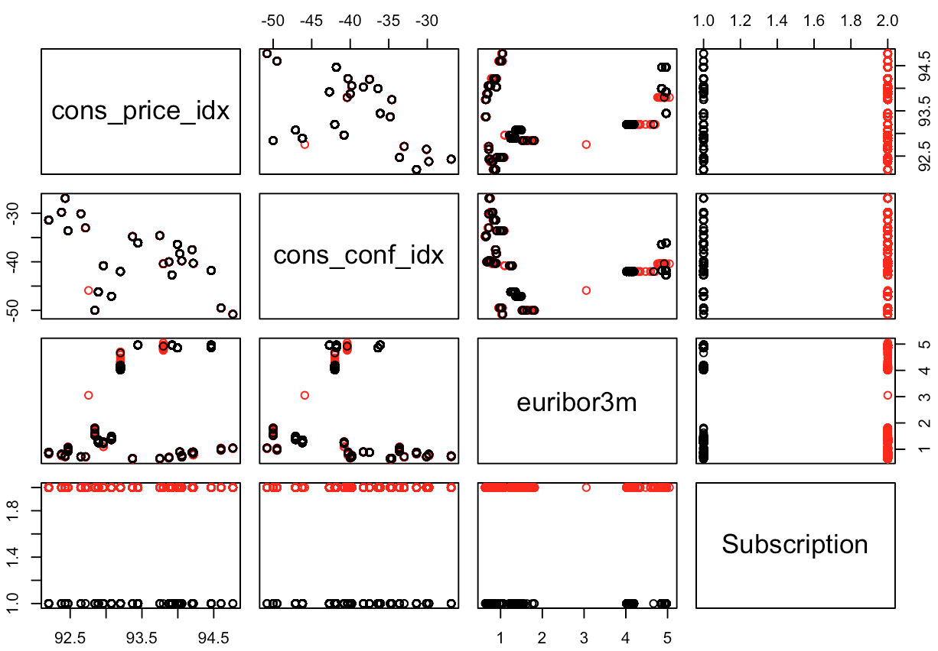

Variable removal

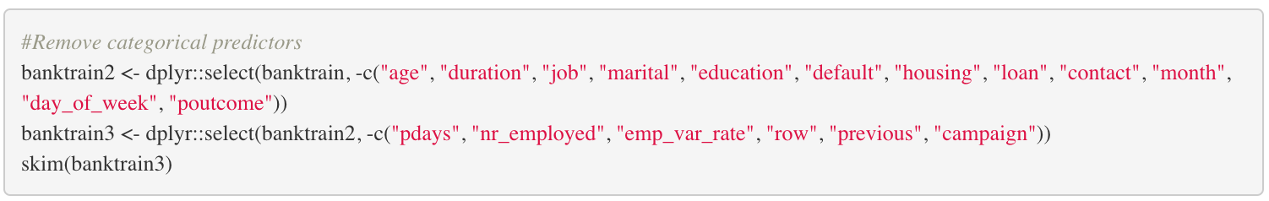

Subscription yes no results check

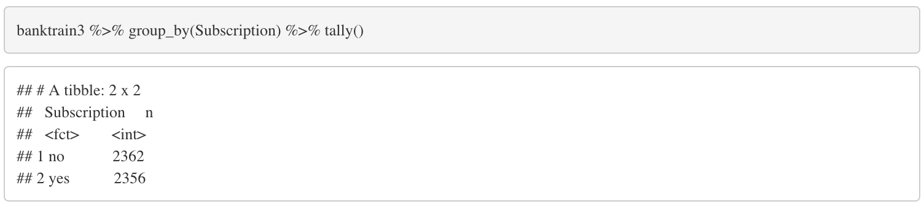

3D Graphical Display

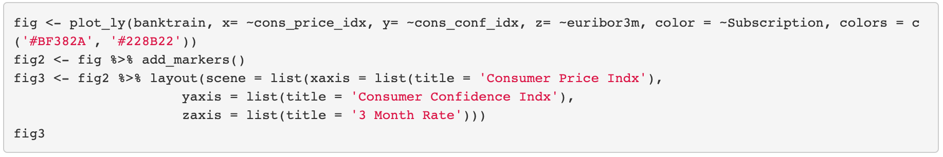

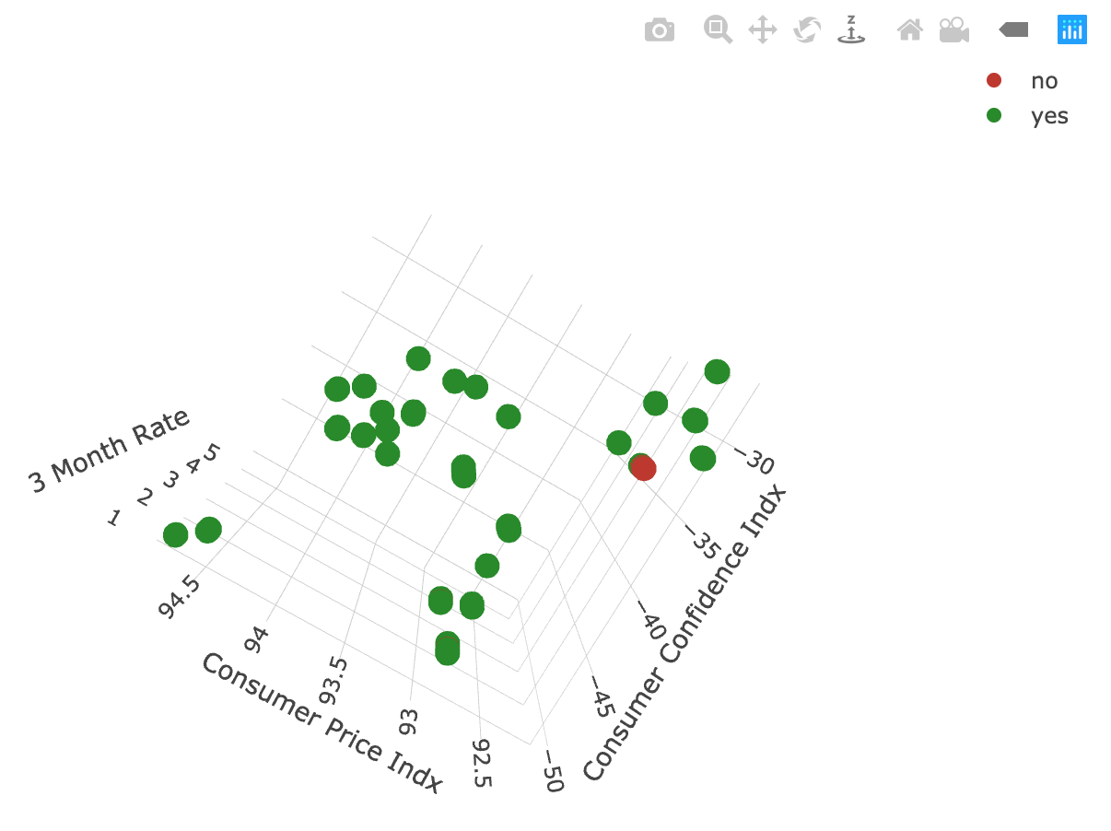

Subscription Results Check

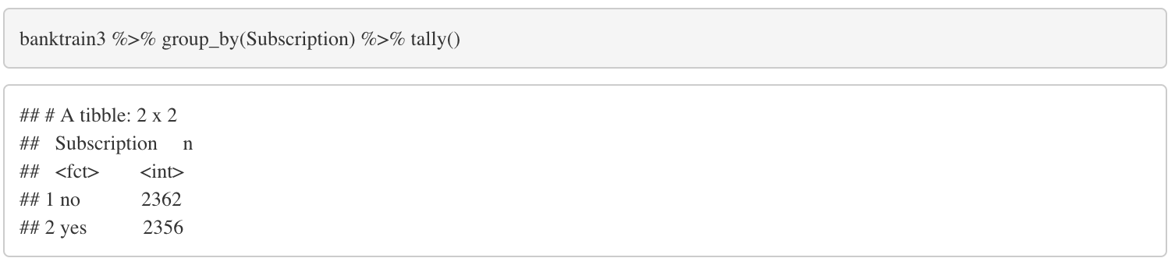

LDA Code / Confusion Matrix / Accuracy, Sensitivity, Specificity

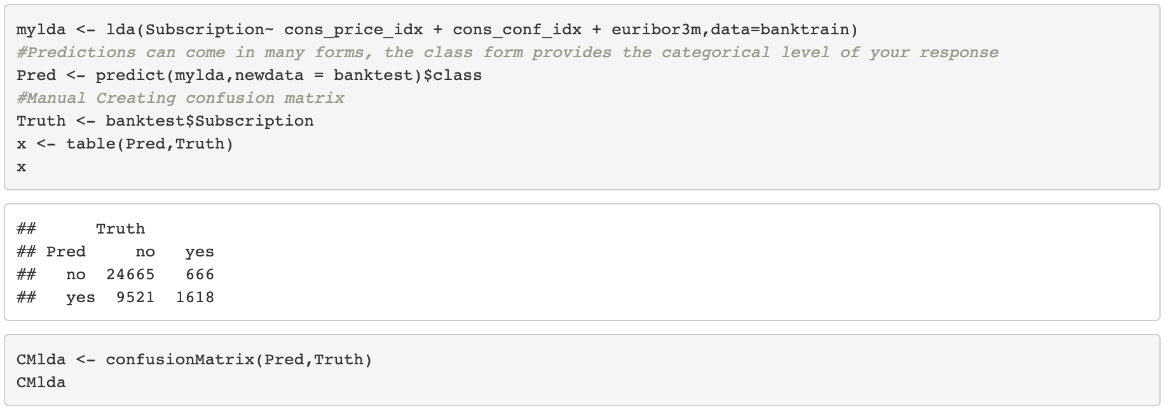

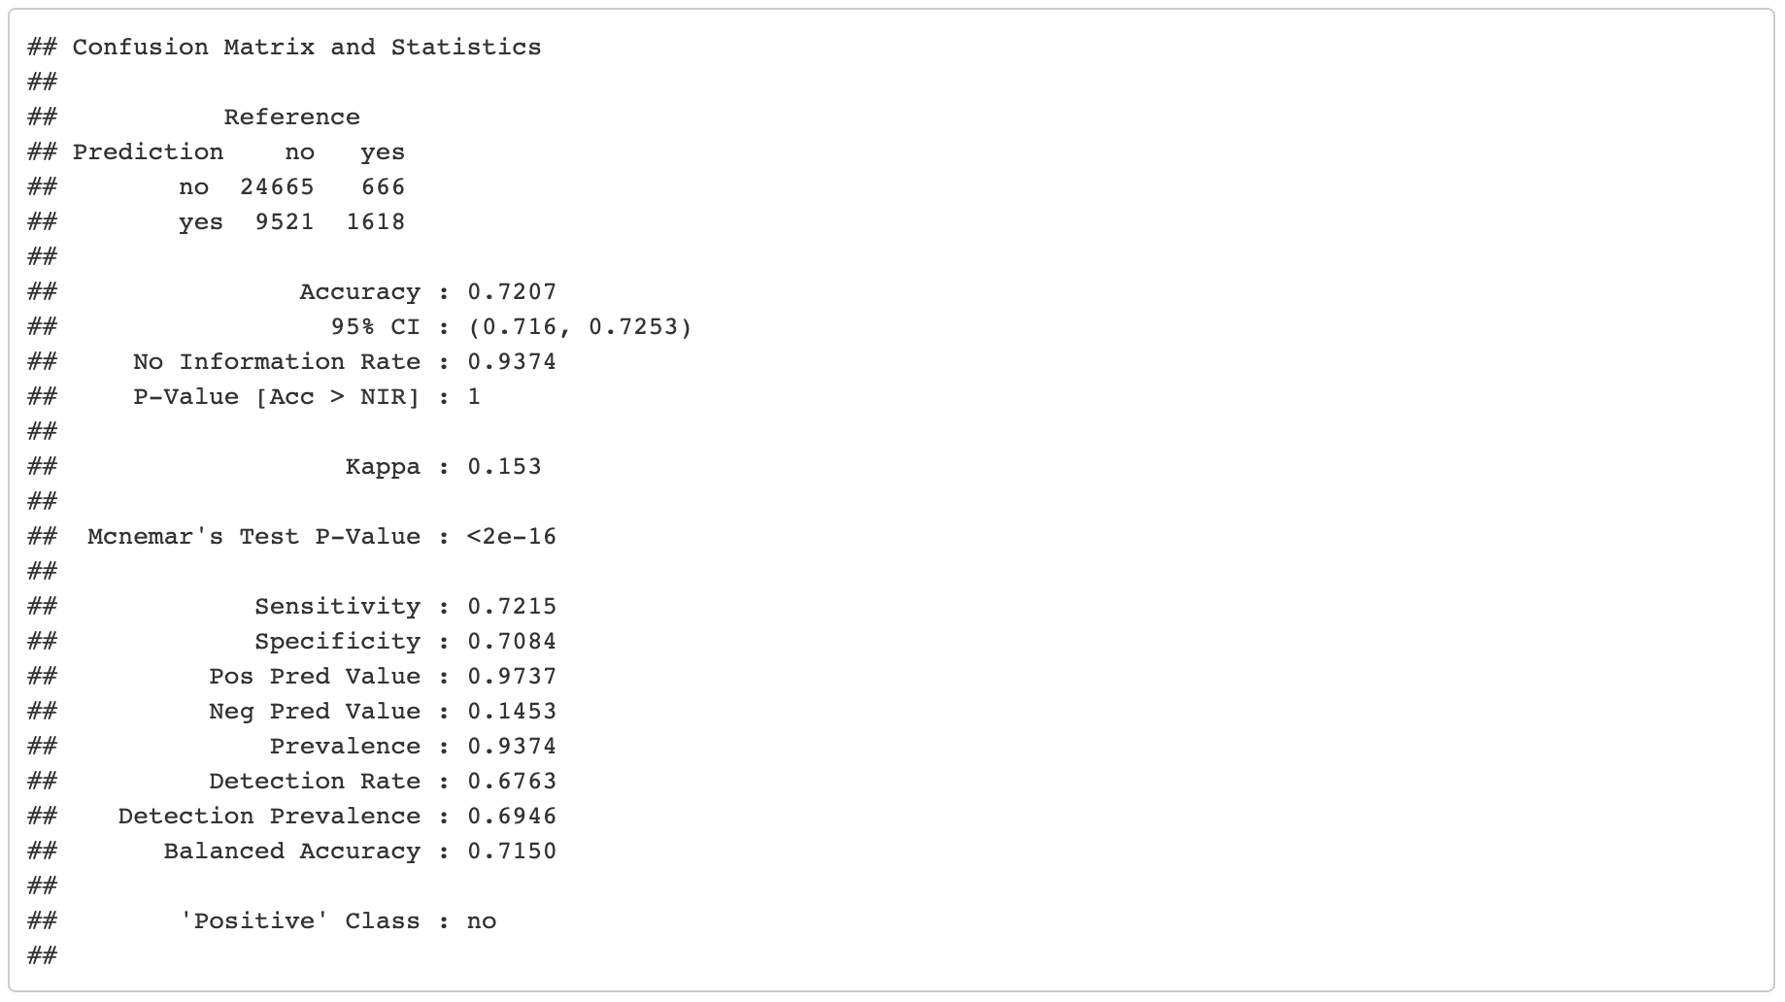

QDA Code / Confusion Matrix / Accuracy, Sensitivity, Specificity

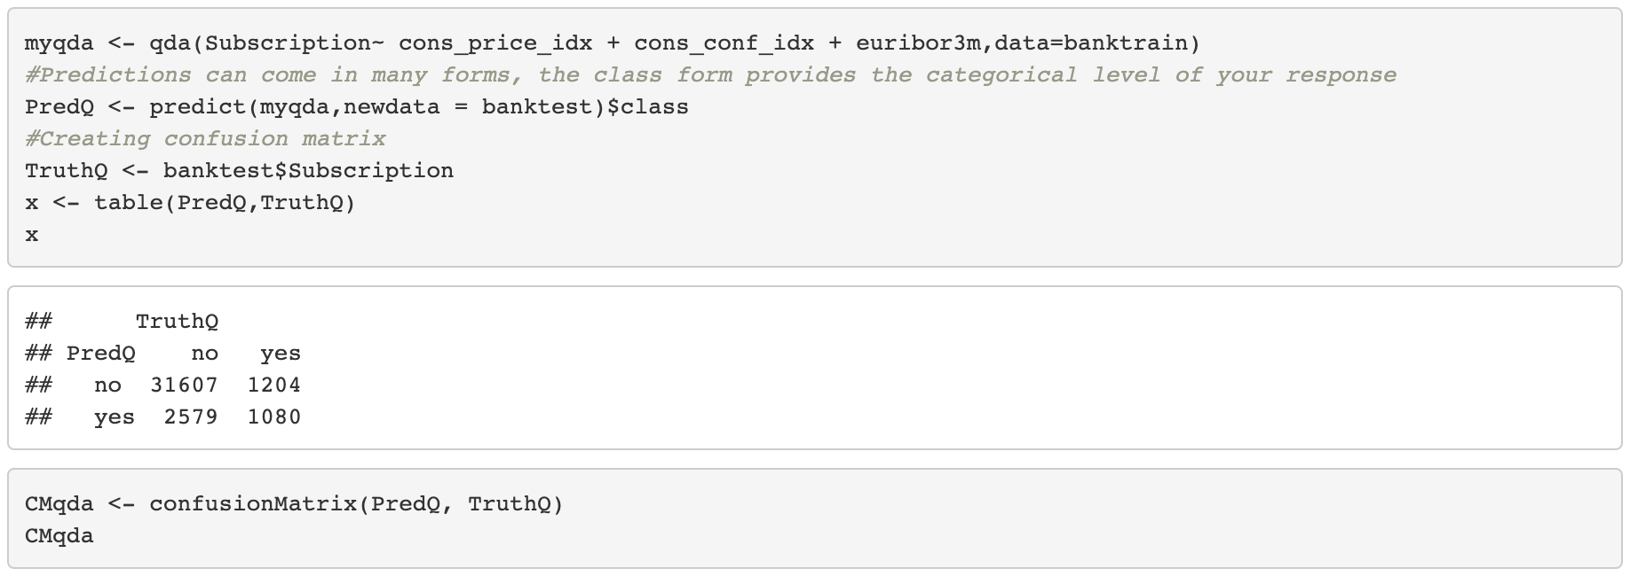

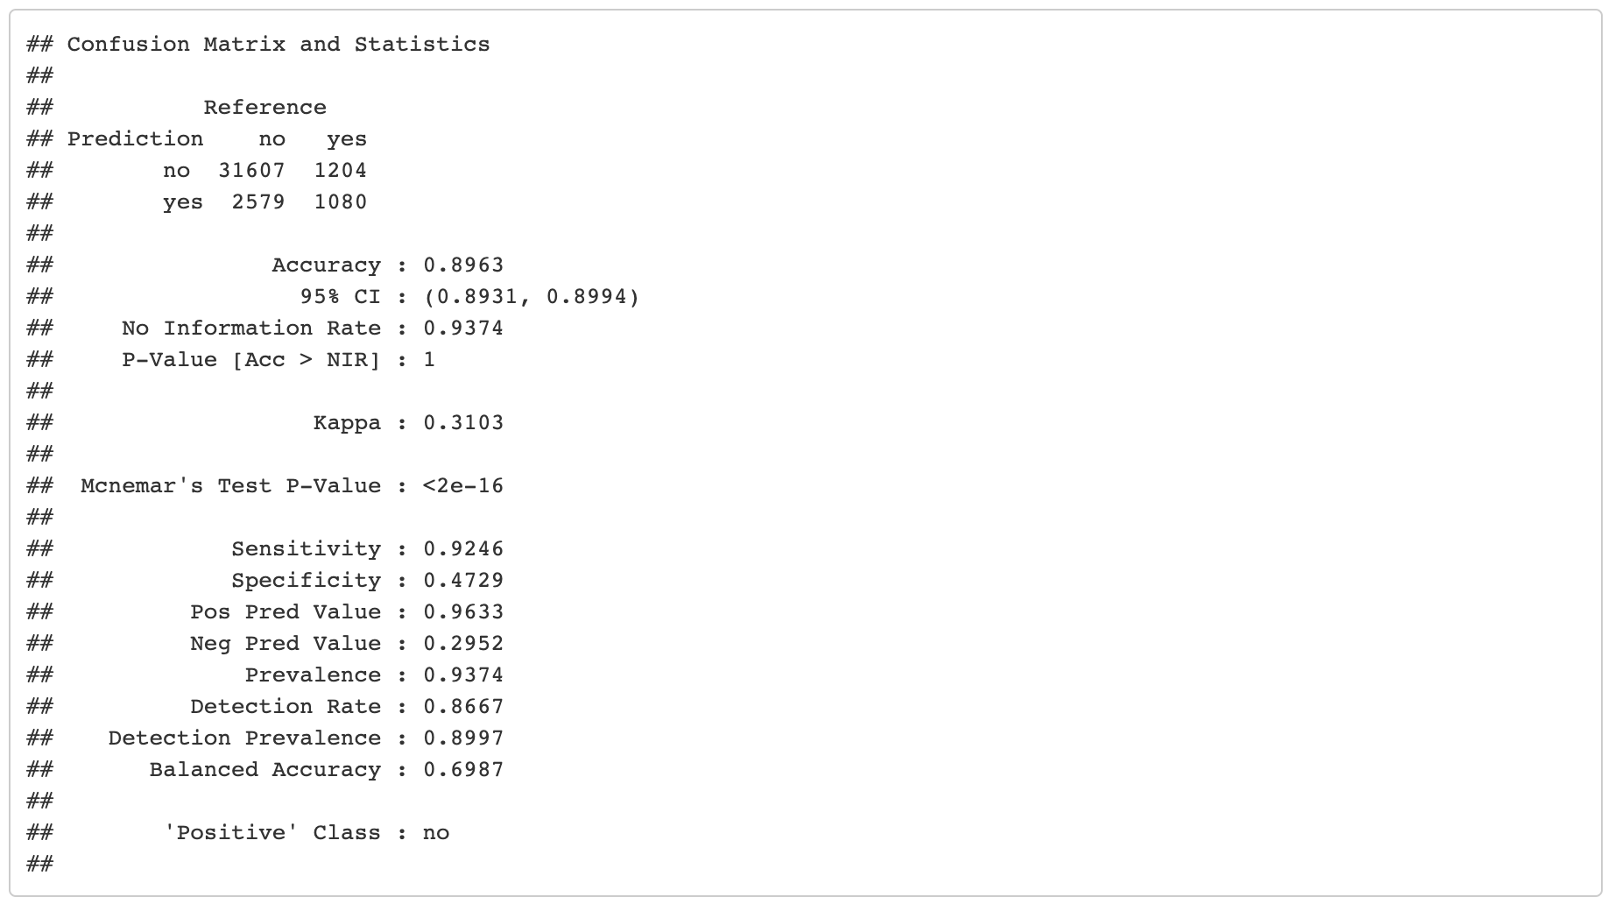

* + - 1. K-Nearest Neighbor (KNN)

One of the other model options explored was the K-nearest neighbors model (KNN). Running on a full, reduced, and engineered model, we ran 100 different iterations with k from 1-100 with a 10-fold cross validation set to maximize the ROC value(caret parameter). Using the base model with an optimal k-value of 67, we were able to achieve a pretty high starting accuracy from the raw, undersampled data set.

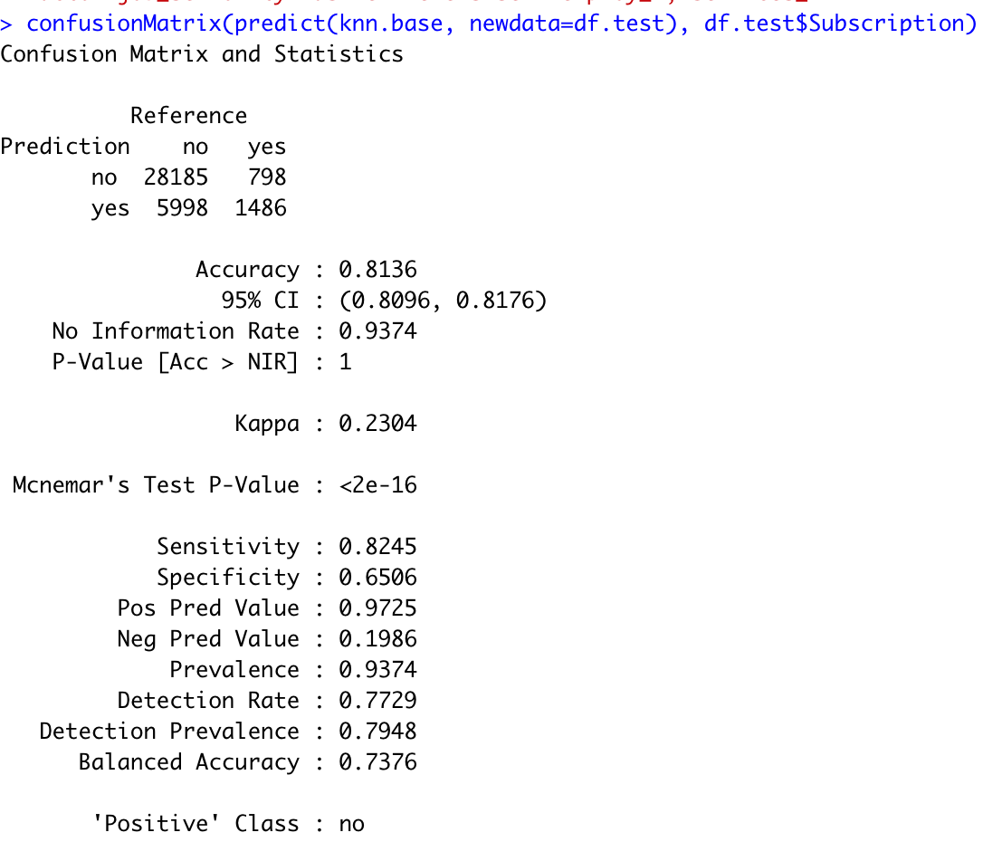

Even though we had a fairly good starting point, we wanted to focus on reducing the total features in the model to alleviate concern of overfitting the model. After a combination of taking only significant features from our logistic regression model and performing some additional ad hoc EDA, we were able to reduce the total features in the model from 21 to 9 without a very noticeable reduction in specificity.

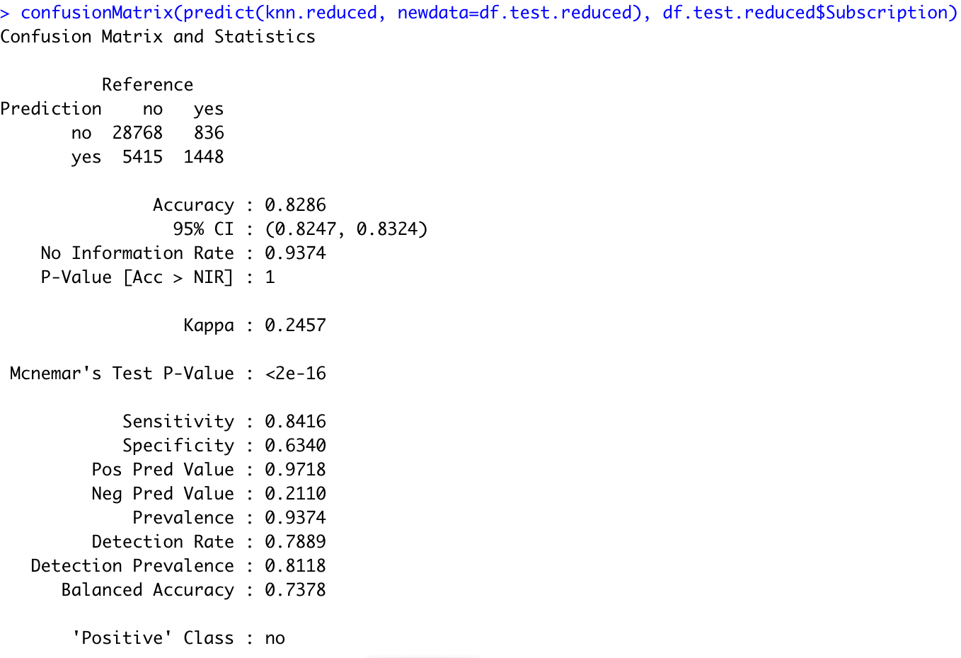

In order to further optimize the model, we sought to combine features to create a categorical interaction by utilizing a concatenation of each category, separated by an underscore character. By utilizing the new features of “month_marketing campaign” and “job_seniority(age over 60)” we were able to remove 4 more features. Additionally, checking correlation between features allowed us to select only one of three highly correlated features (emp_var_rate). The result was an extremely similar score with an even more reduced model comprising 5 features (4 if you don’t count the response). Although we were not able to achieve a much higher score, dropping 16 features has allowed for a much stronger model that is less prone to overfitting. Therefore, we’d argue that we were successful in creating an improved model over the raw data set.

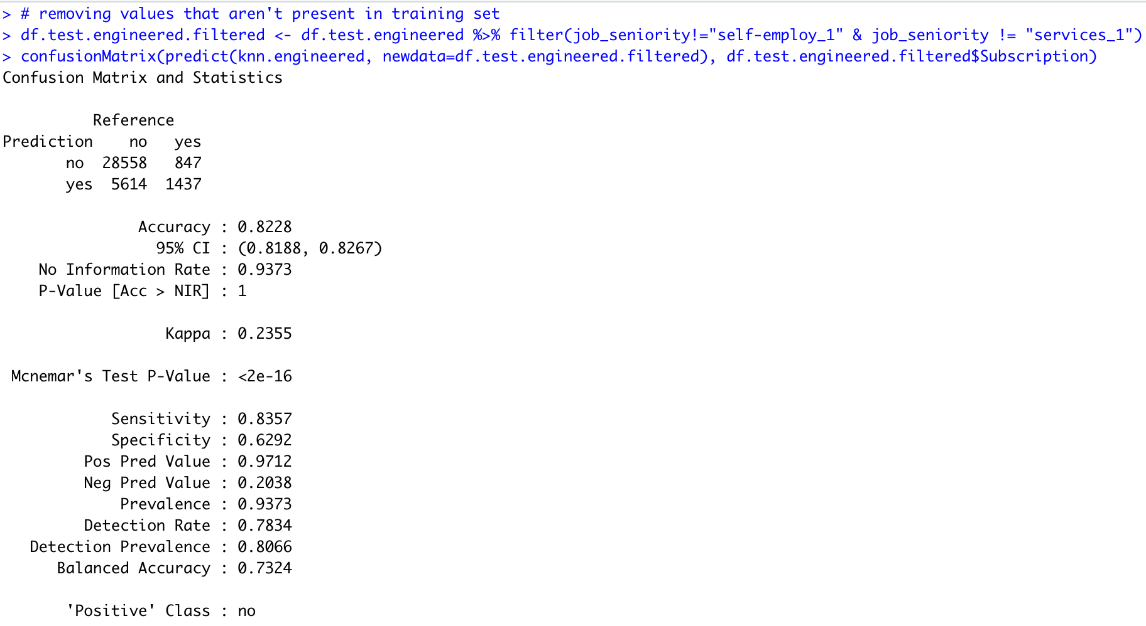

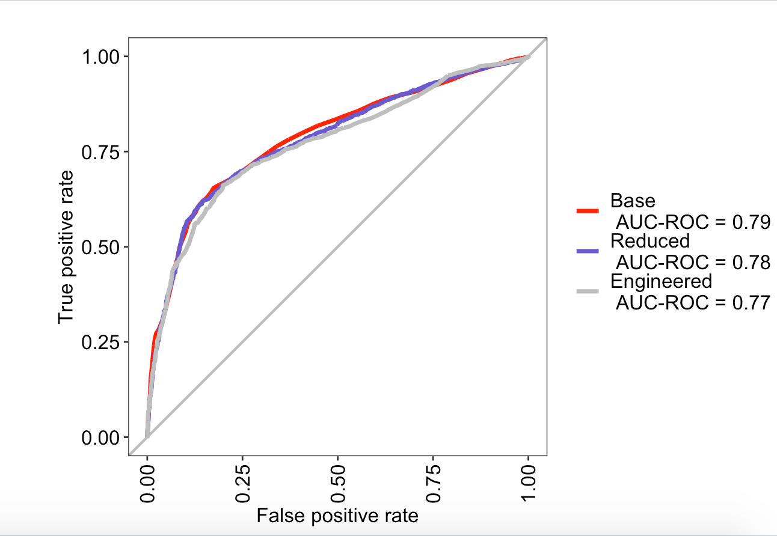

* + - 1. Random Forest: **Branum**

One of the options we explored was the Random Forest model due to its ease of interpretation and the ability to model complex behavior without adding extra complexity such as interactions. Additionally, the Random Forest model is often used as a first model by many data scientists to create a baseline upon which to compare other models to. In order to get an idea of what the baseline prediction ROC was for the random forest model, we started by training the model on all predictors of the undersampled data set. Using all of the features from the example below, we can see that we were able to achieve an ROC of 0.79 [Figure XX] which is approximately equal to the logistic regression model and is an improvement over the KNN model. The accompanying confusion matrix accuracy, sensitivity, and specificity can be seen in Figure XX.

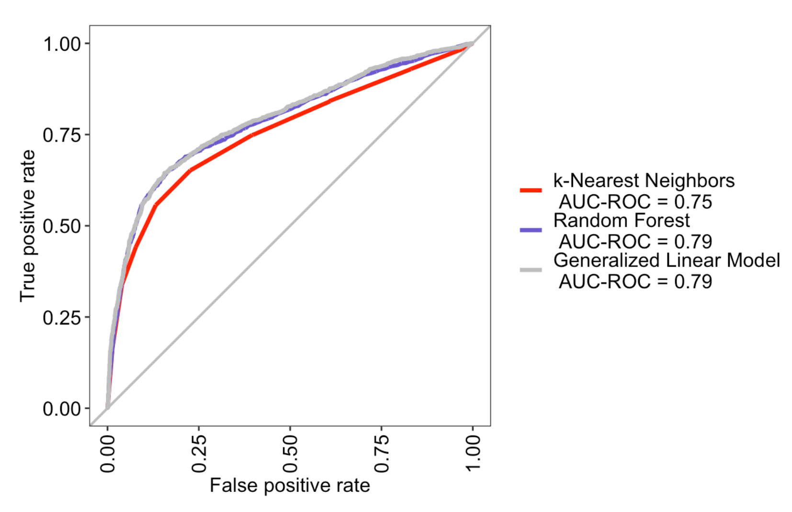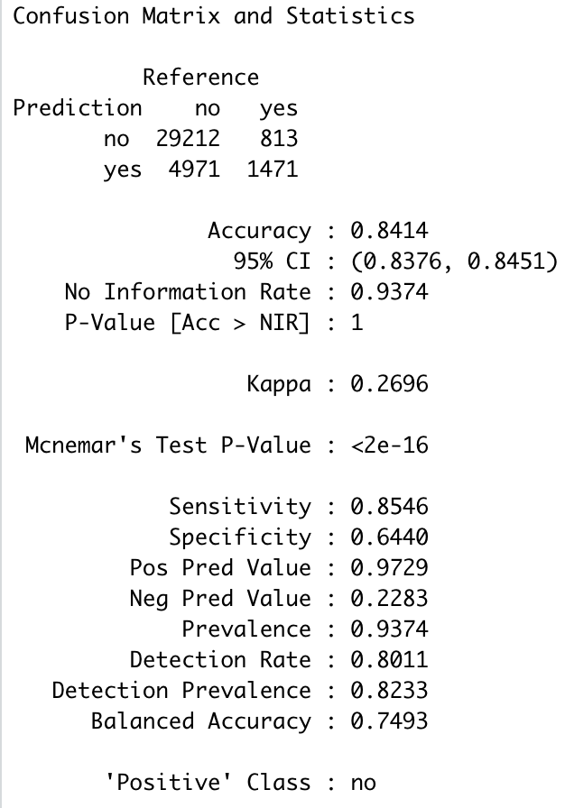

The next steps were to see which variables were not needed, such as to reduce the possibility of overfitting our model. By checking the significant variables from the logistic regression base model (which used the same predictors), we narrowed down to only those features that bore significance to the base case model.

In the process, we dropped from 21 features to 9 features and were able to attain a very comparable model score yet reduce model complexity and boost interpretability. See the ROC curve in Figure XX, the confusion matrix accuracy, sensitivity, and specificity in Figure XX.

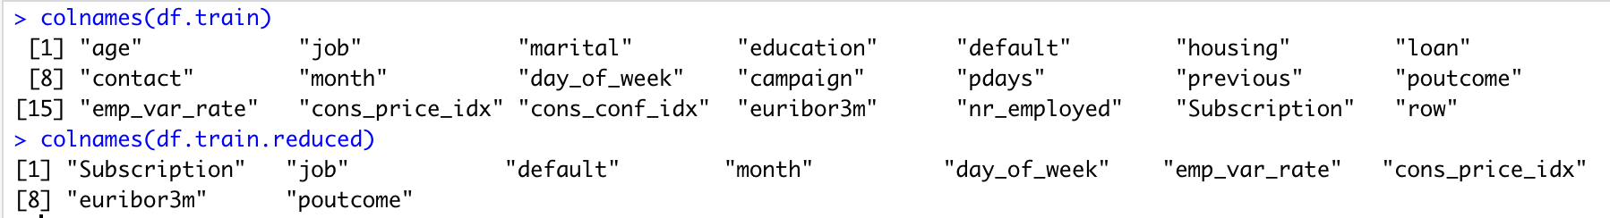

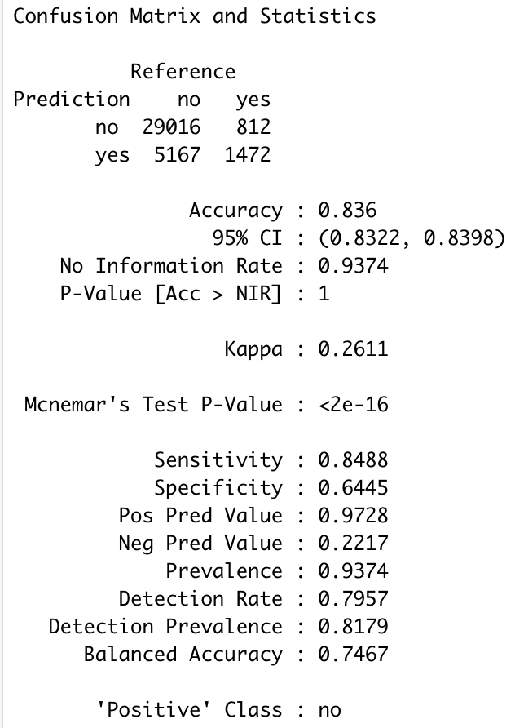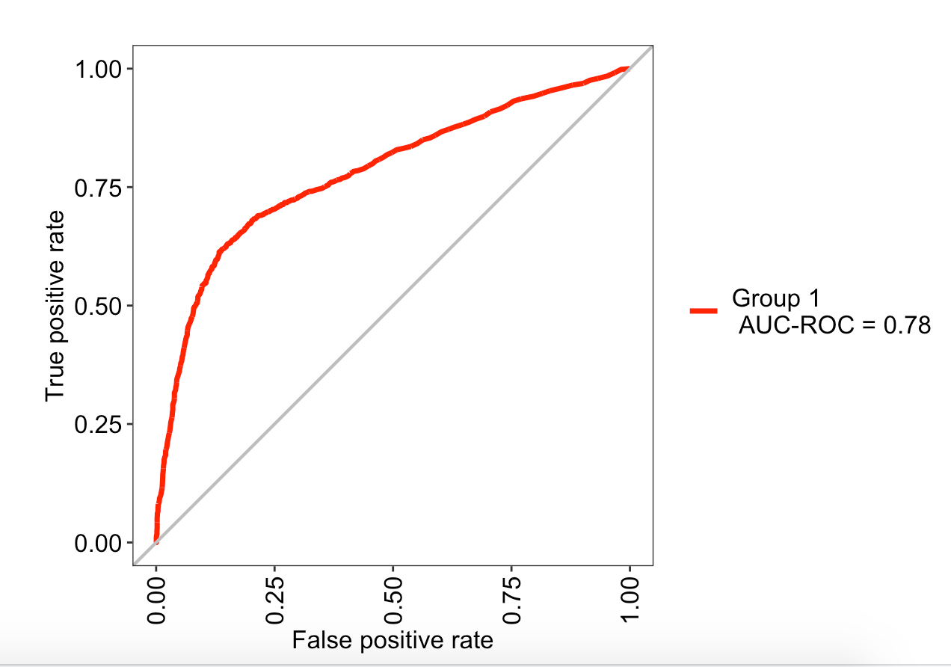

Now that we were able to achieve a very similar score with a much more lean model, we utilized some exploratory analysis to create some “engineered” features that may improve score. Some of the things that stood out was that job, month, age (those over 60 correspond to the high number of “retiree” jobs), and success of the marketing campaign were all pretty crucial identifiers in the data. By implementing some “interactions” between the factor levels from combining multiple features and an underscore, we were able to better see seperation like in the plots below. Our new interaction variables were *month_marketingcampaign* displayed in Figure XX. Another variable was *job_age* which can be seen in Figure XX.

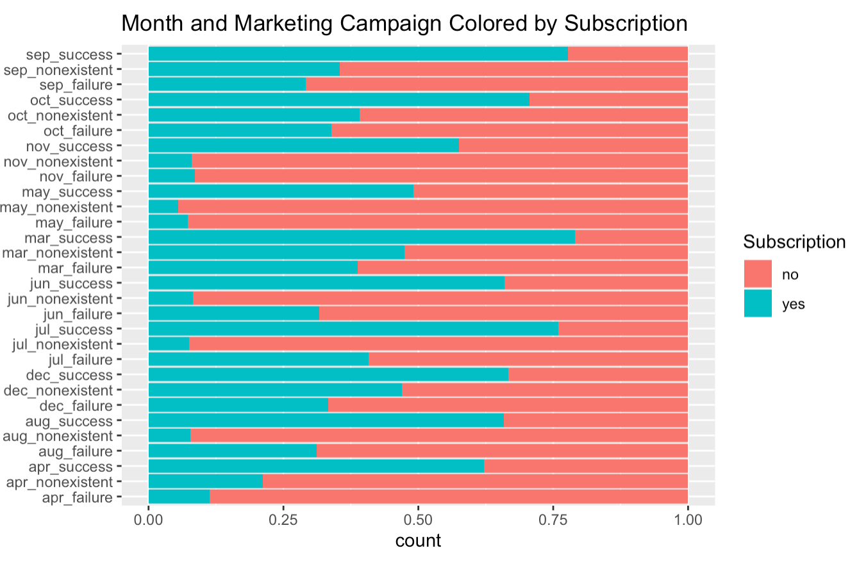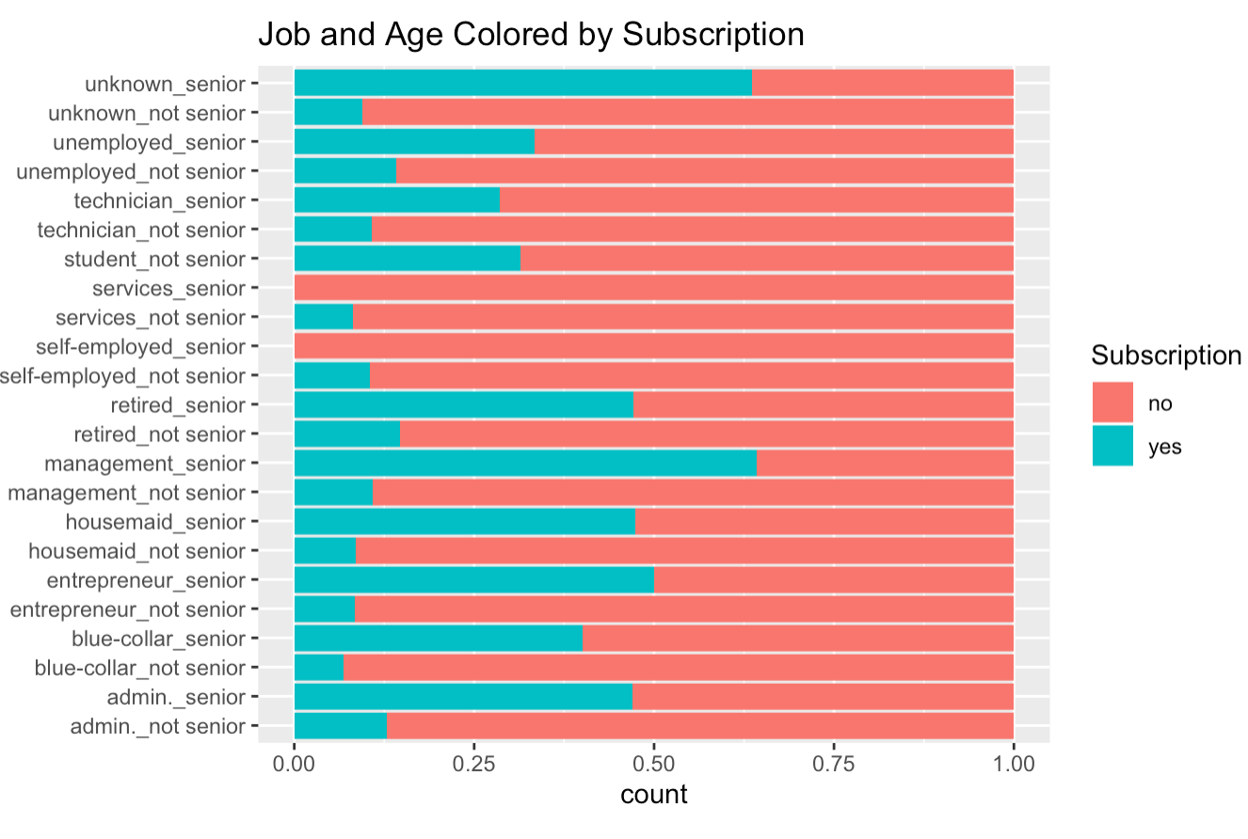

By adding these two features and dropping the four features used to make them, we were able to further simply our model. Additionally, we realized the high correlation between the remaining numeric features and opted to keep emp_var_rate because it explained the highest correlation with the other numeric features, thus we believe it to better represent the trends that we sought out in the remaining three numeric features. After dropping down to only five features, we were able to obtain a very similar sensitivity/specificity as in the most complicated model and only took a 0.03 reduction in ROC while significantly increasing model interpretability and reducing likelihood of overfit.

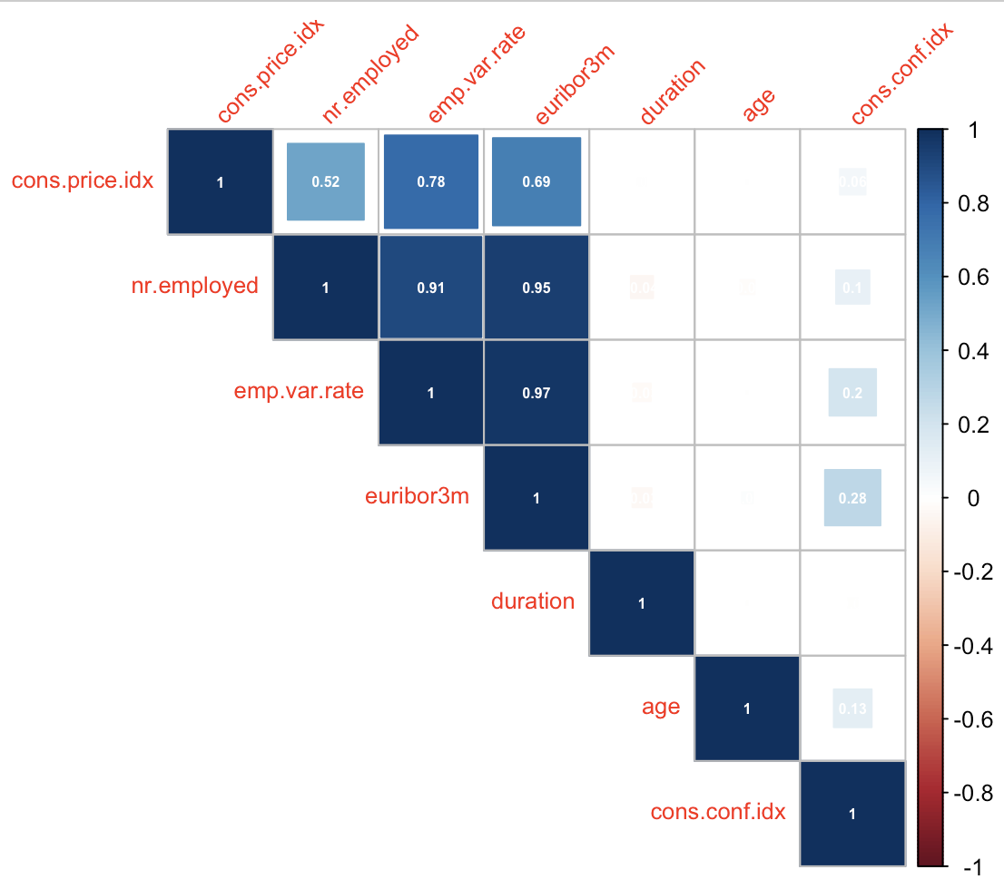

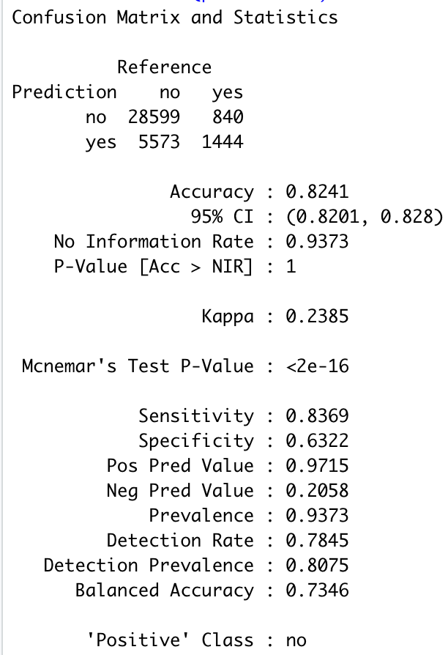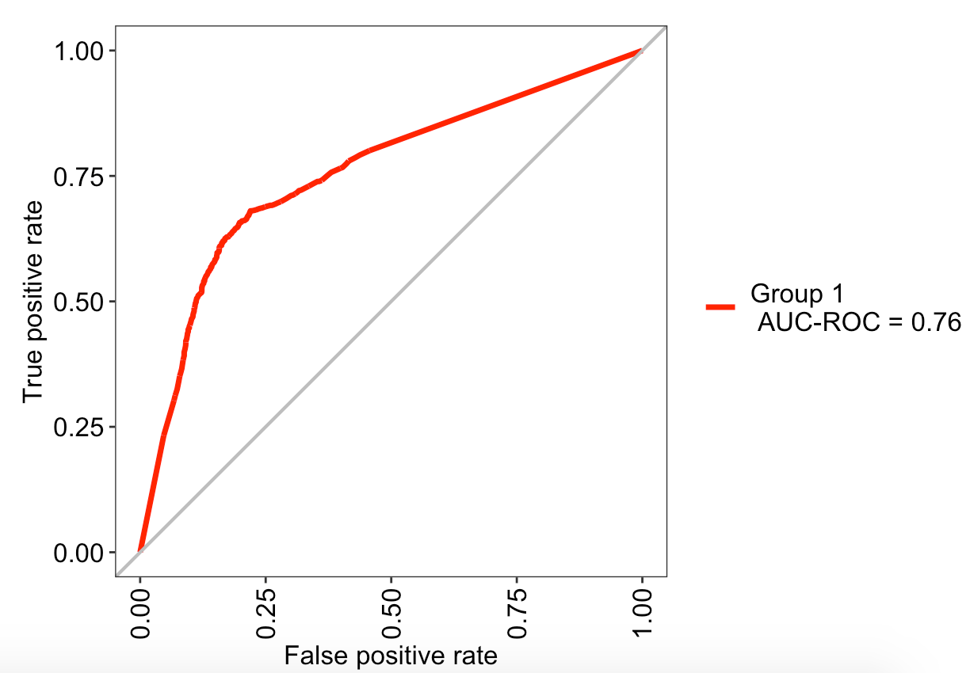

## Main Analysis Content **Jaclyn/Branum/Josh**

### Overall report of the error metrics on a test set or a CV run. Also, if the two best models have error rates of .05 and .045, can we really say that one model is outperforming the other? For ambition, McNear’s test could be helpful in answering that.

|  |  |
| --- | --- |
| **Model** | **Error Rate** |
| Simple Logistic |  |
| Complex Logistic |  |
| Linear Discriminant Analysis |  |
| Quadratic Discriminant Analysis |  |
| K-Nearest Neighbor |  |
| Random Forest |  |

## Conclusion / Discussion **Jaclyn/Branum/Josh**

### The conclusion should reprise the question and conclusions of objective 2 with recommendations of the final model, what could be done to help analysis and model building in the future and any insight as to why one method outshined all the rest if that is indeed the case. If they are all similar why did you go with your final model?

Conclusions about initial logistic regression model

Discussion on using prior probability in classification models

As shown in the results for most of the models tested, the sensitivity of the models predictions was typically lower than the specificity (when “yes” is considered the positive response; note that many of the tables and

# Appendix

## Figure 1

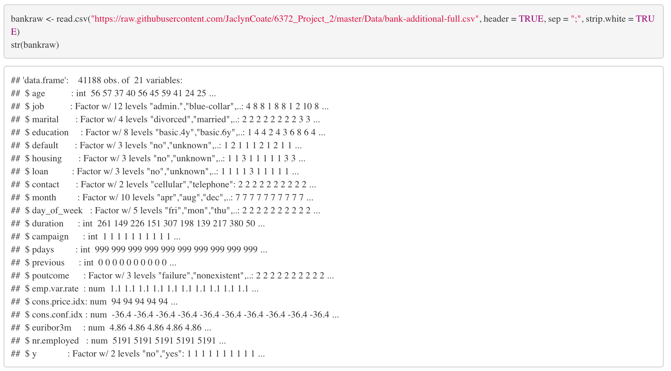



## Figure 2

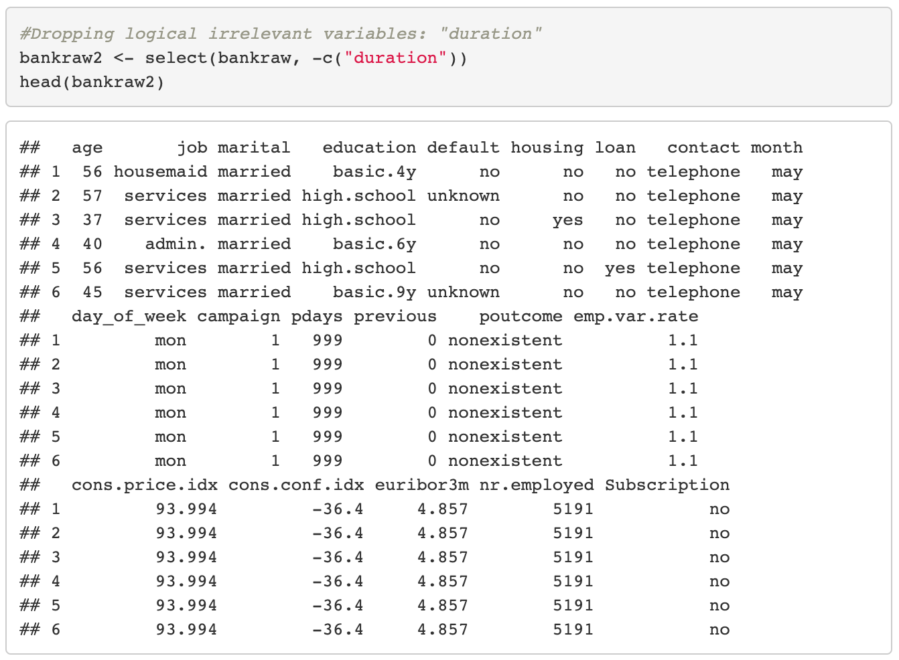

## Figure 3

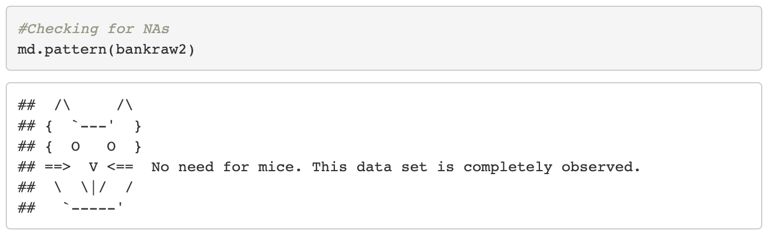

## Figure 4

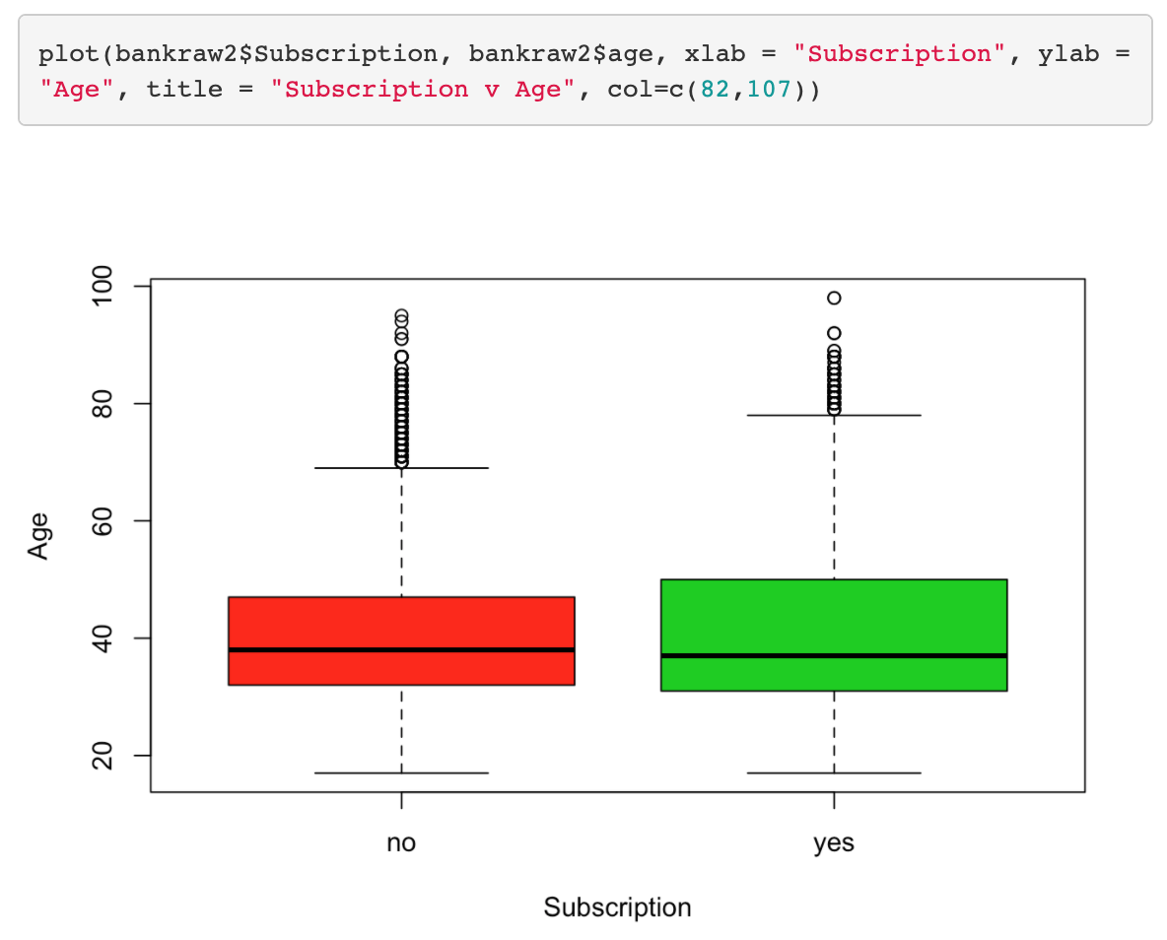

## Figure 5

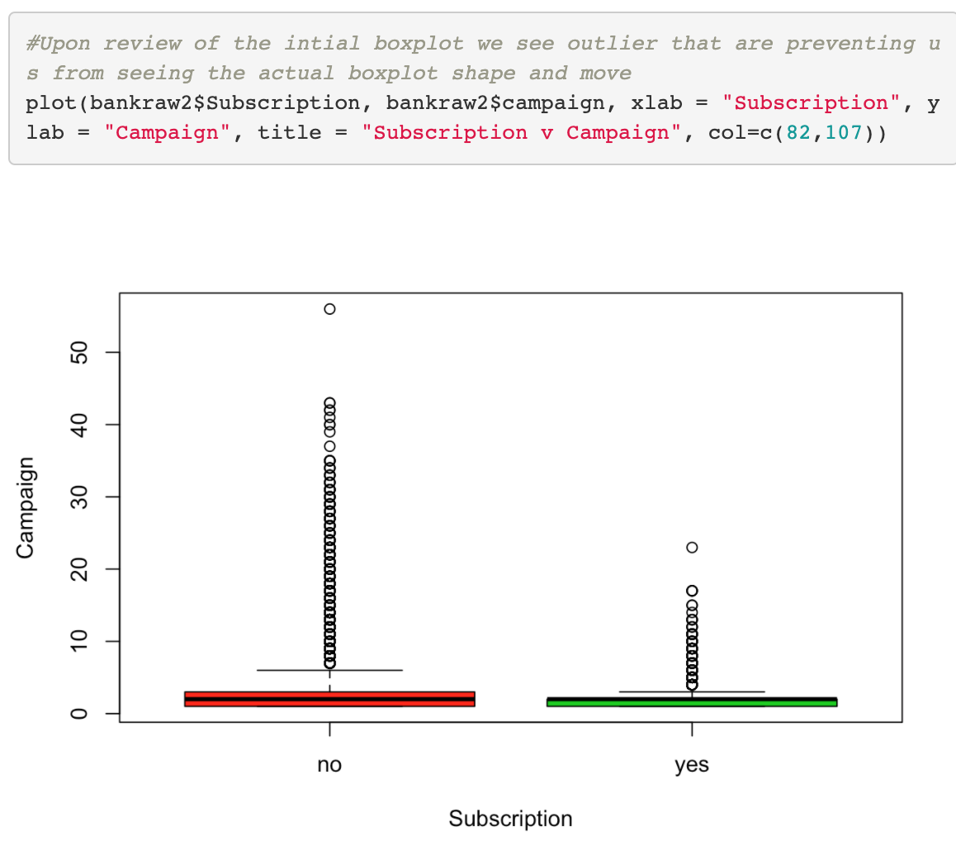

## Figure 6

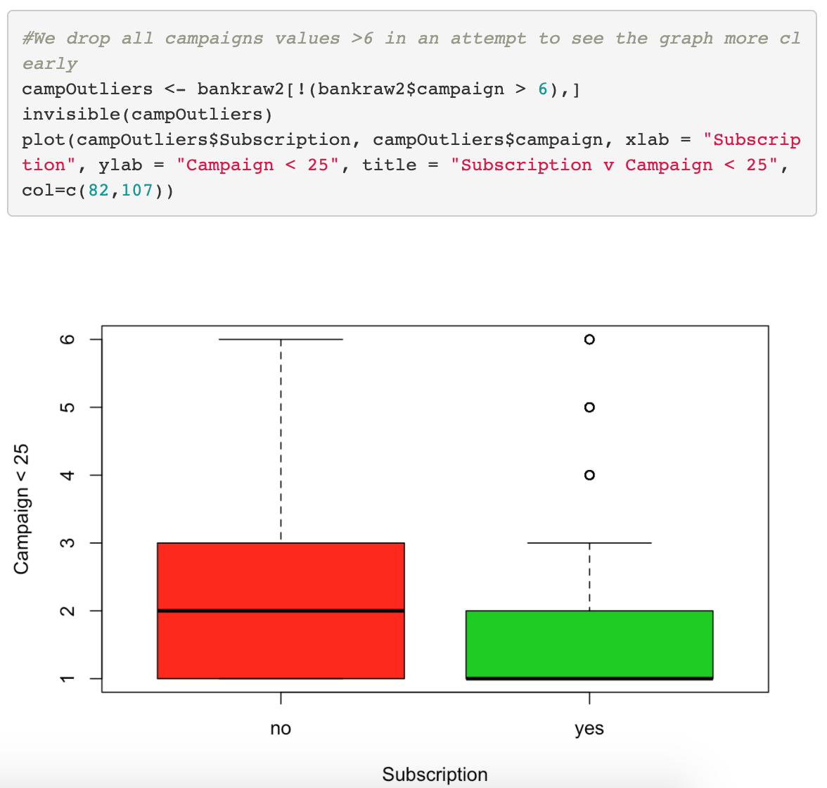

## Figure 7

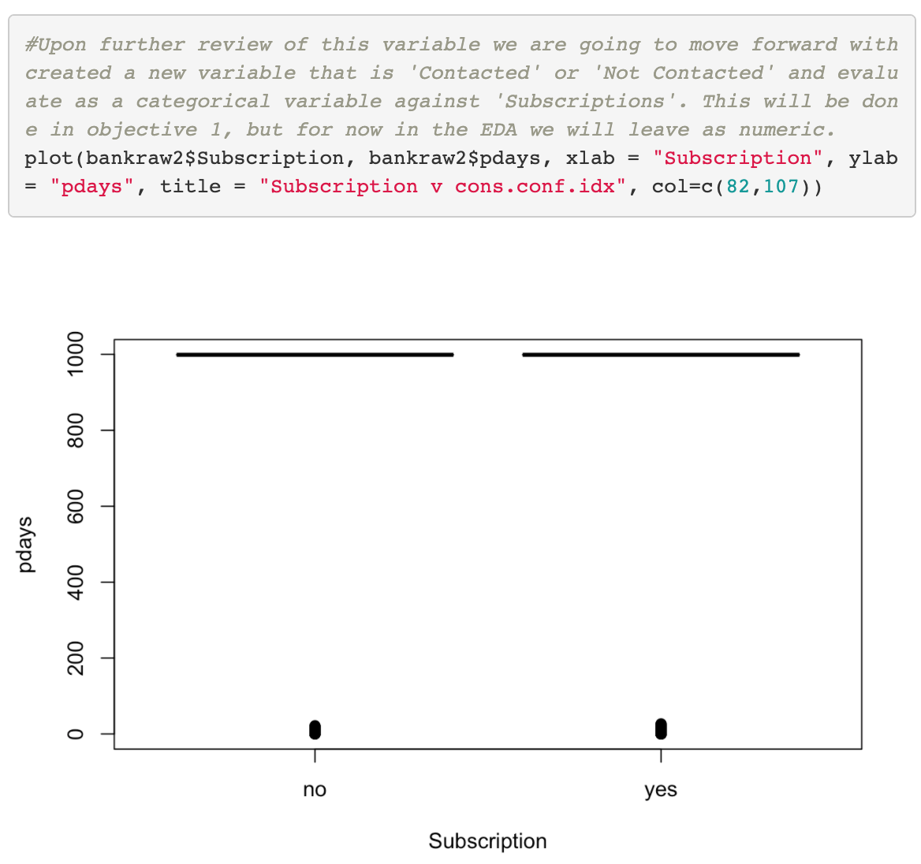

## Figure 8

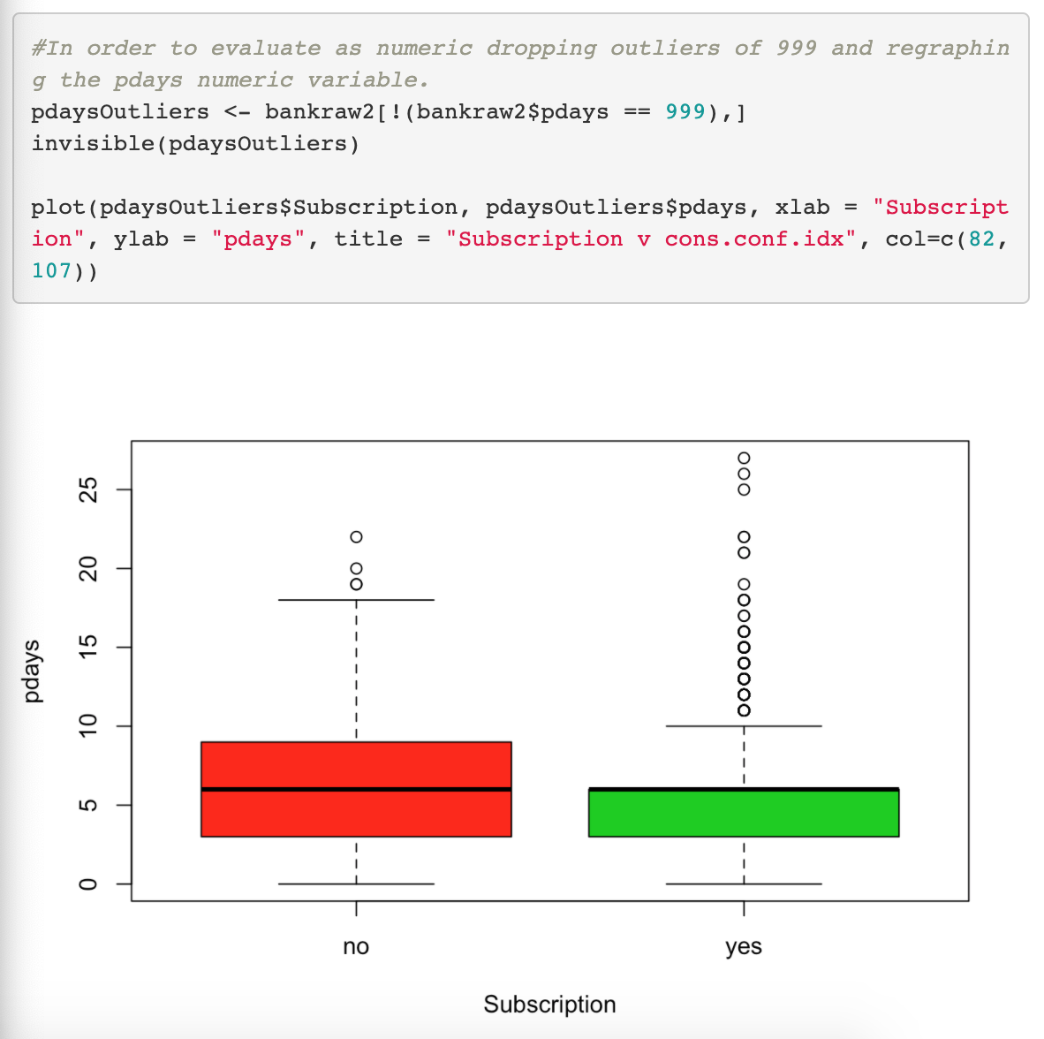

## Figure 9

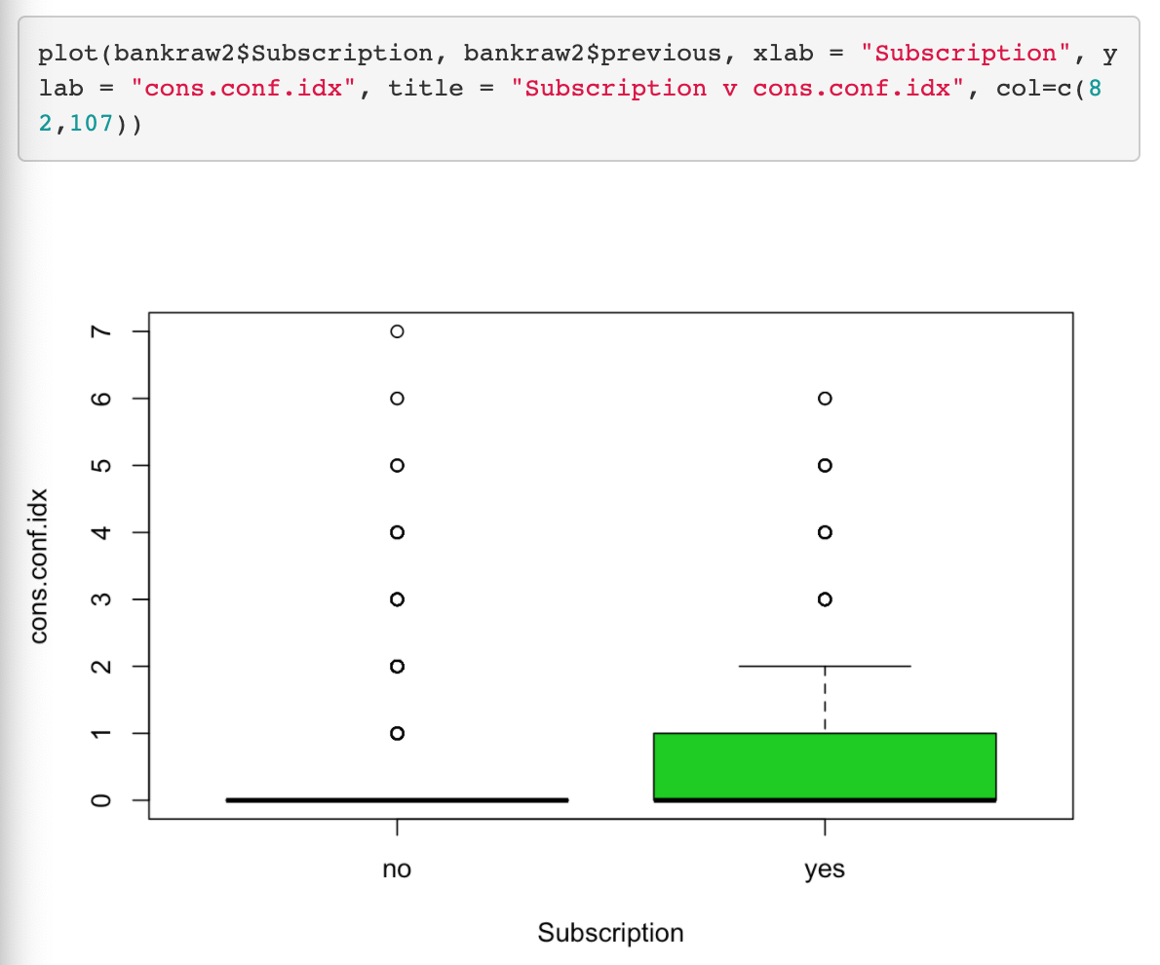

## Figure 10

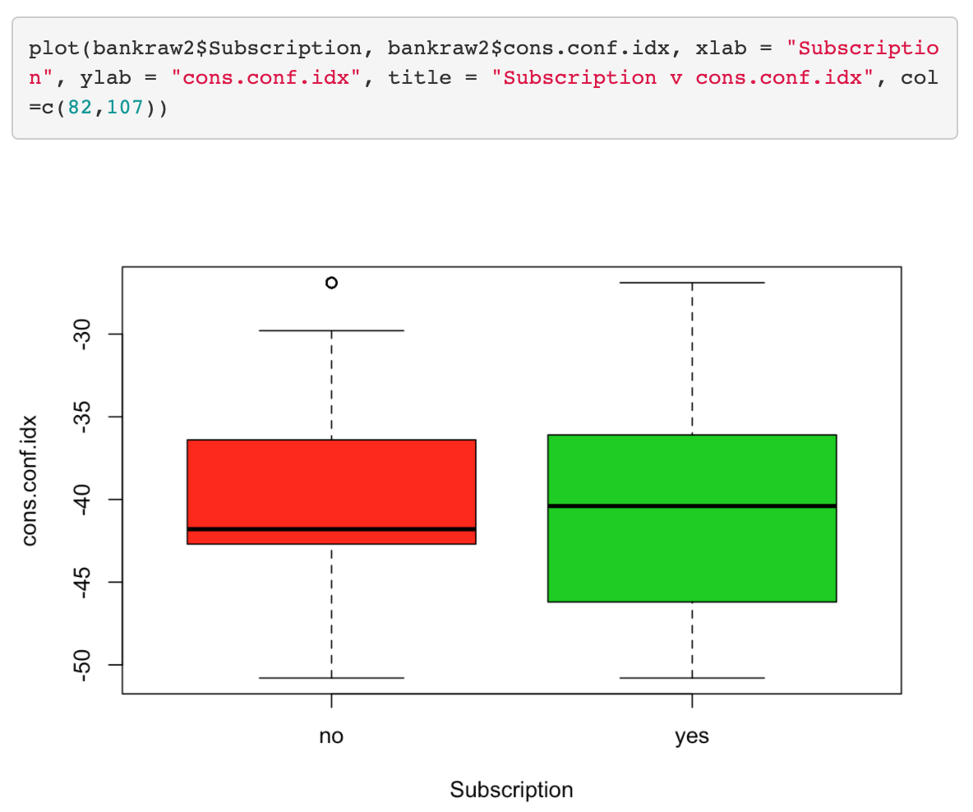

## Figure 11

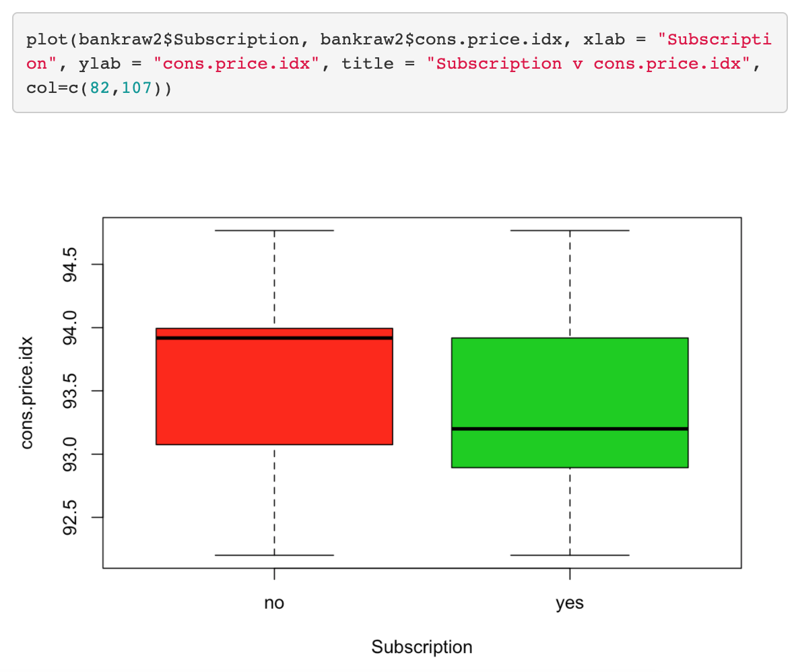

## Figure 12

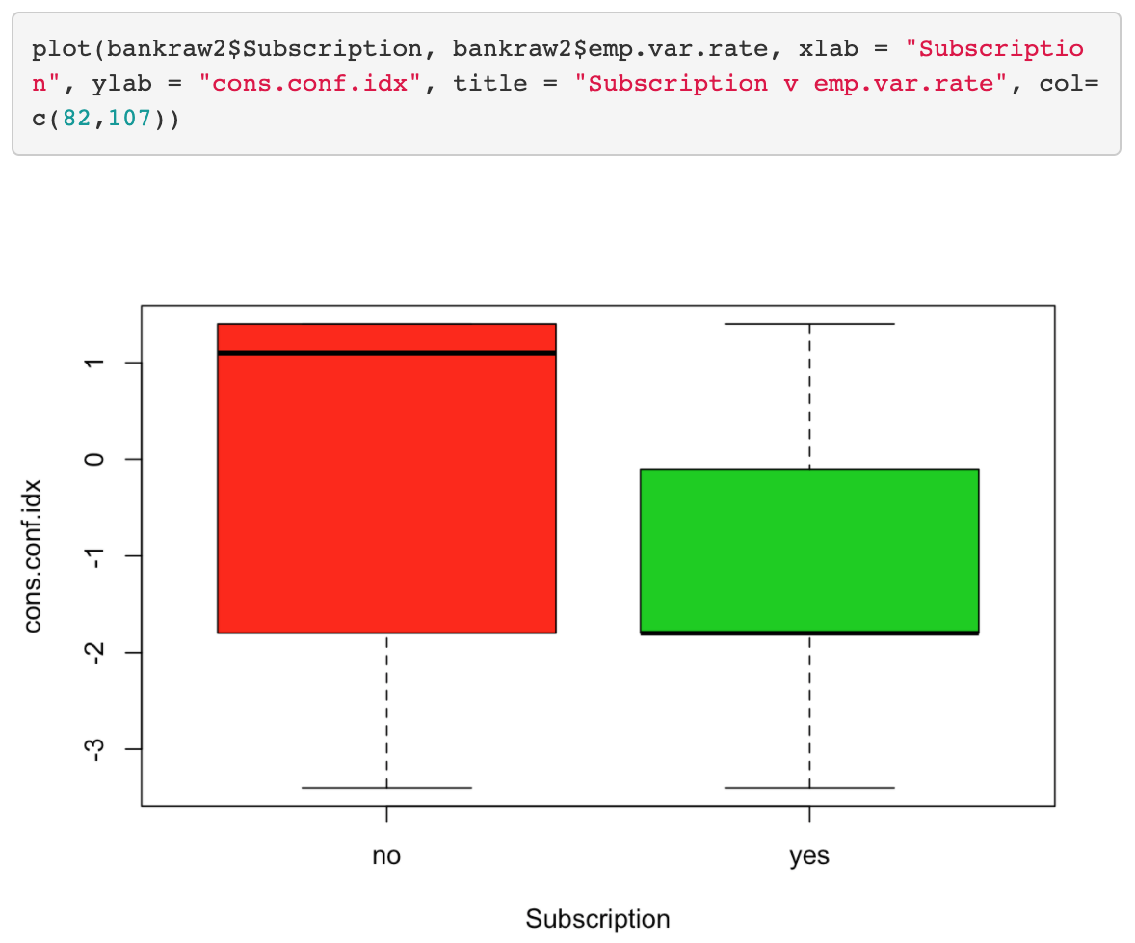

## Figure 13

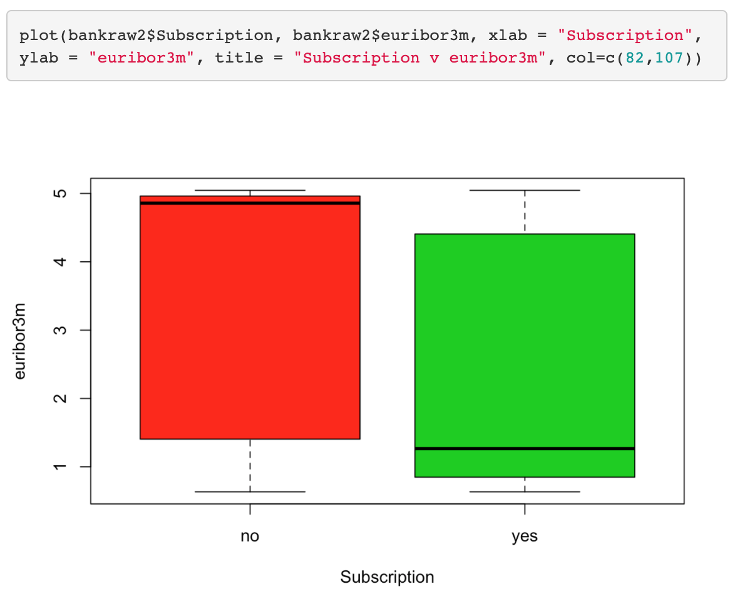

## Figure 14

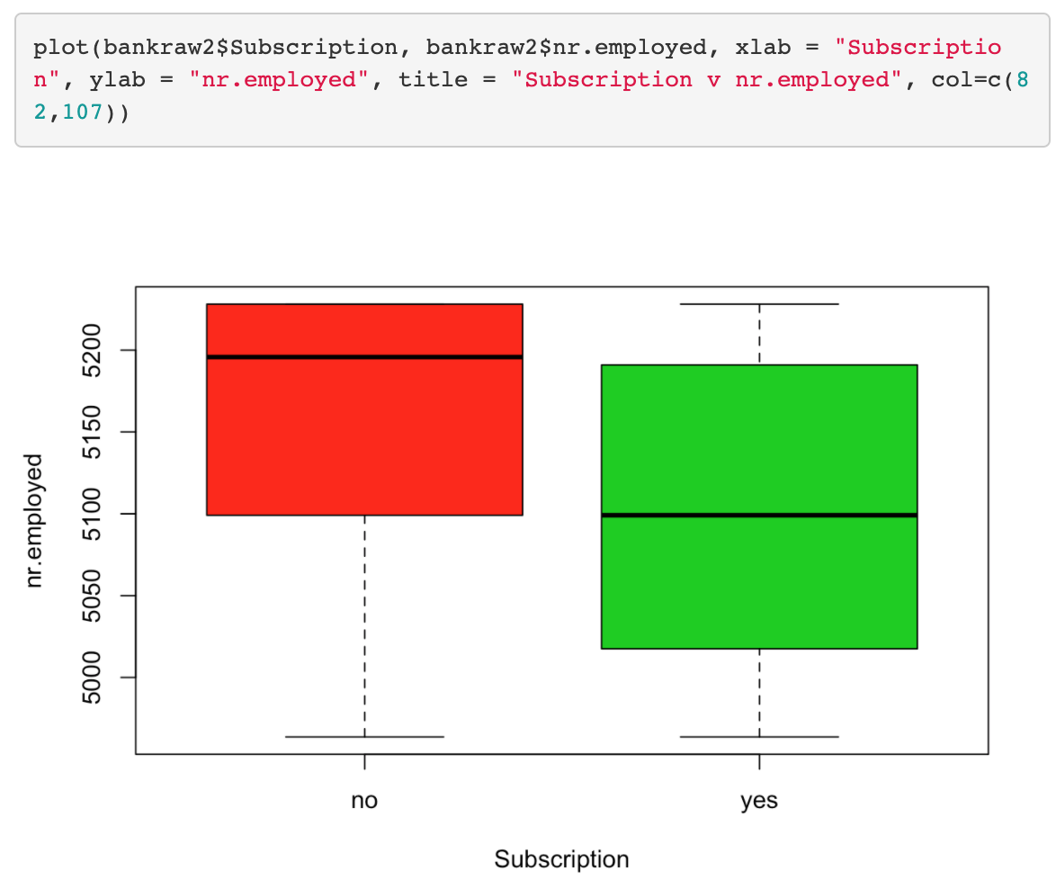

## Figure 15

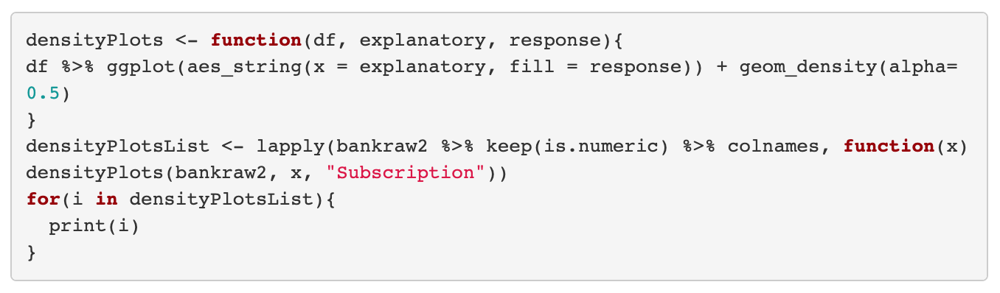

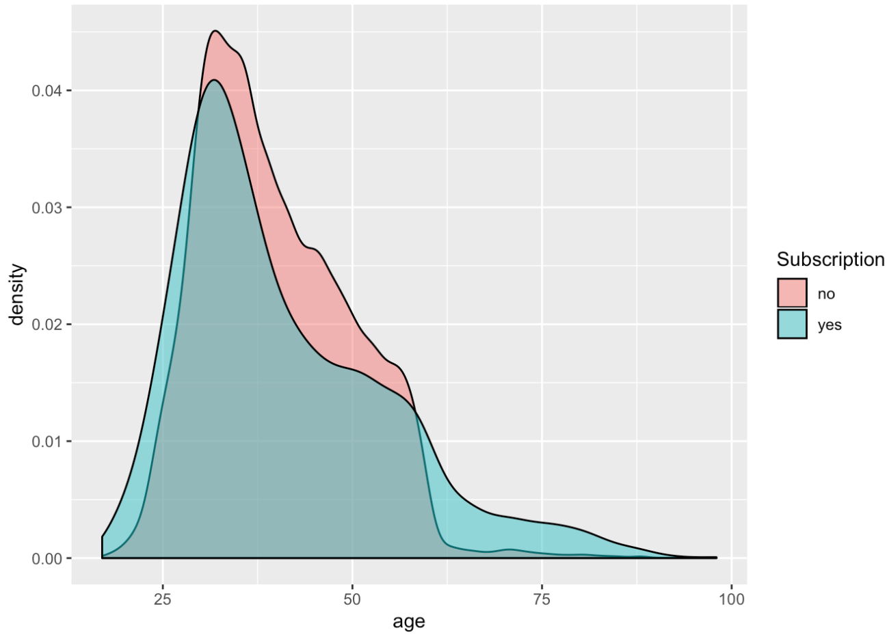

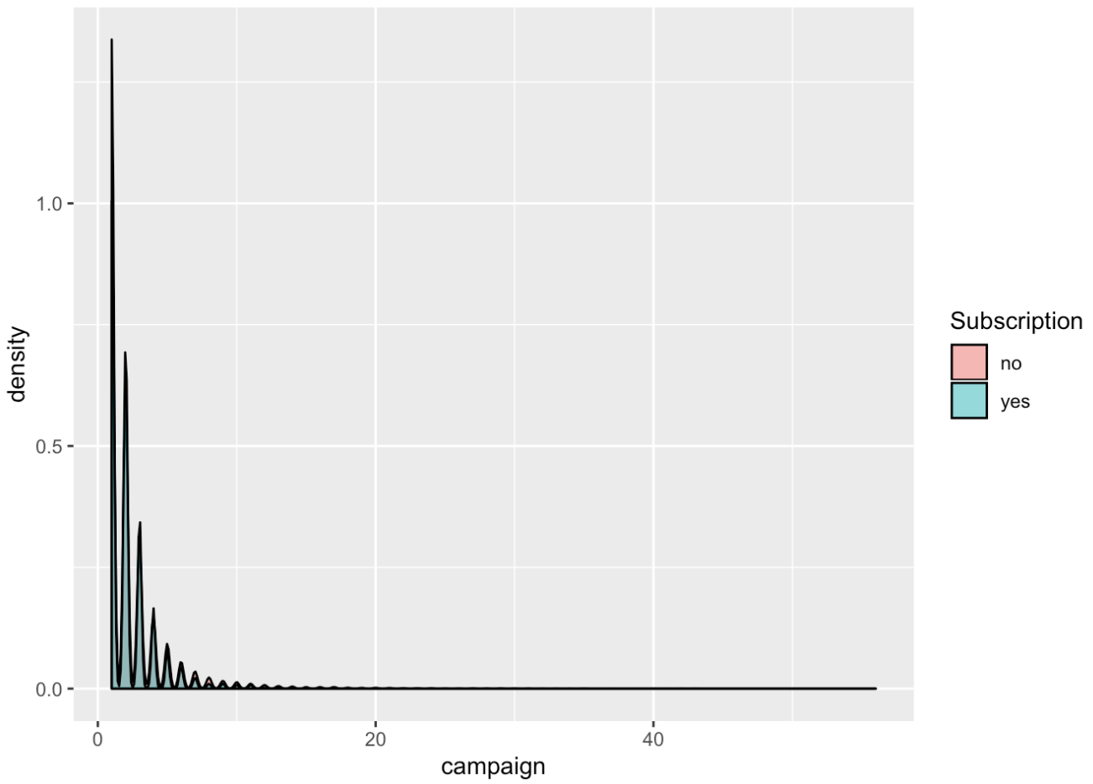

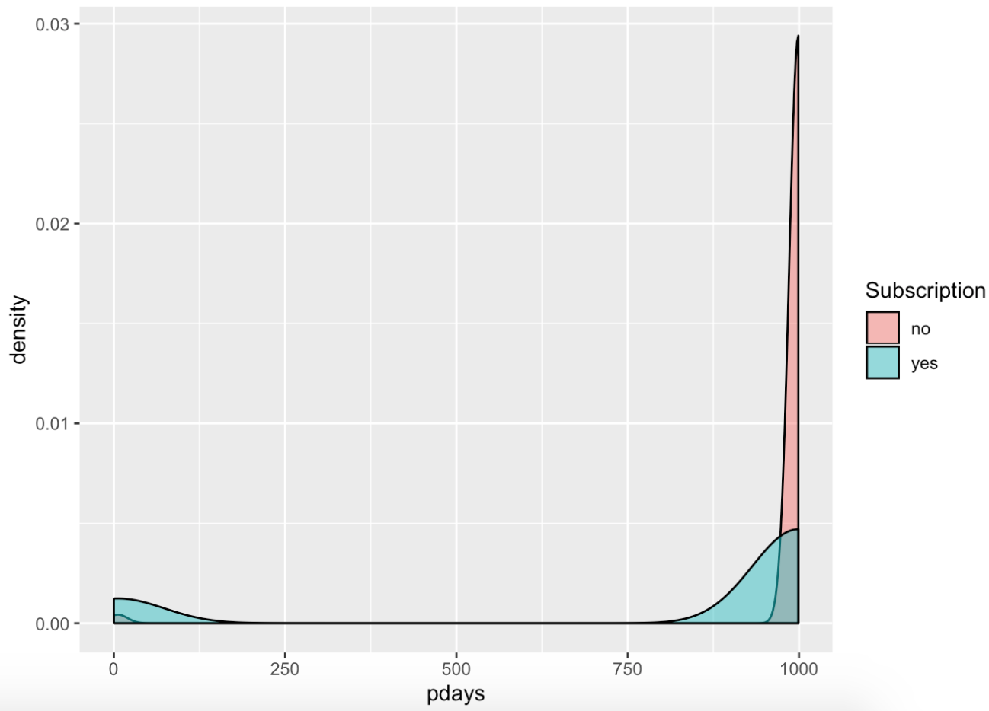

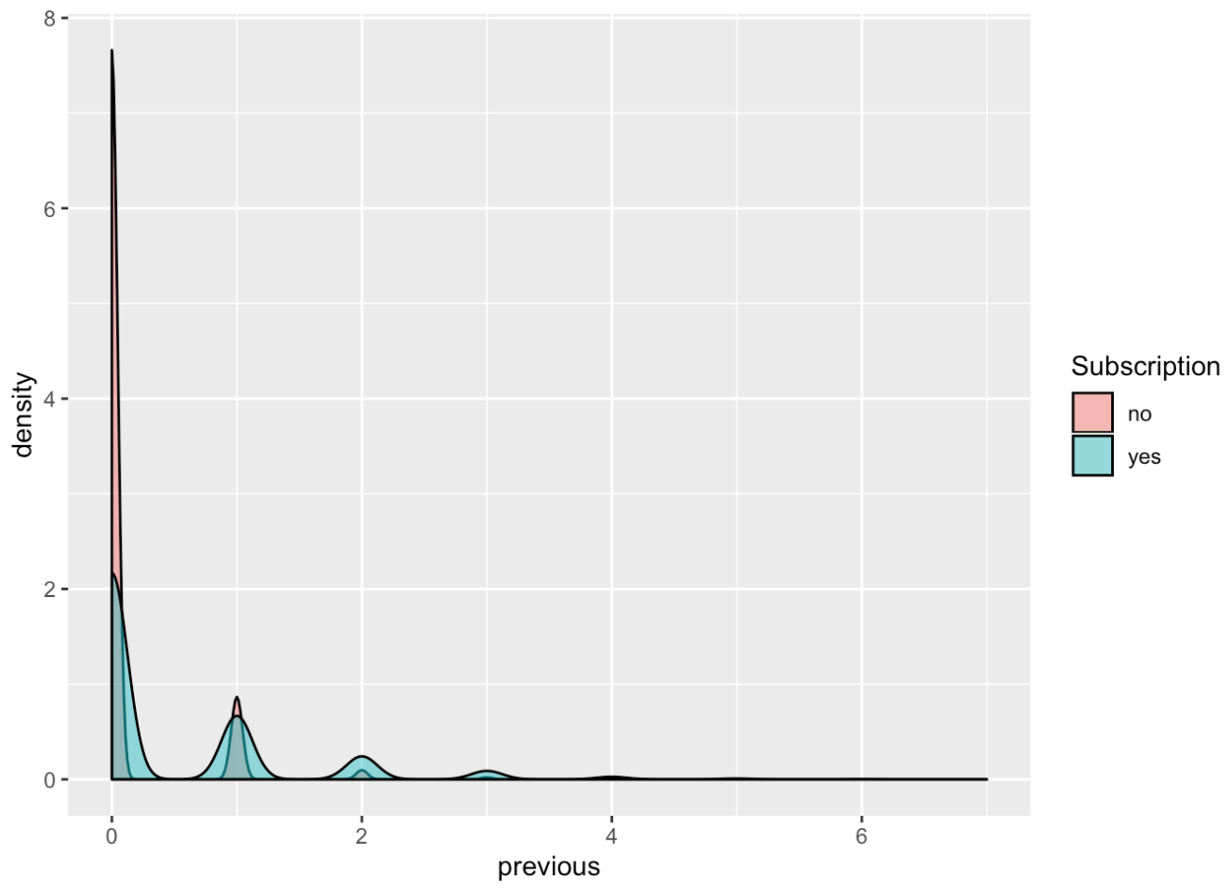

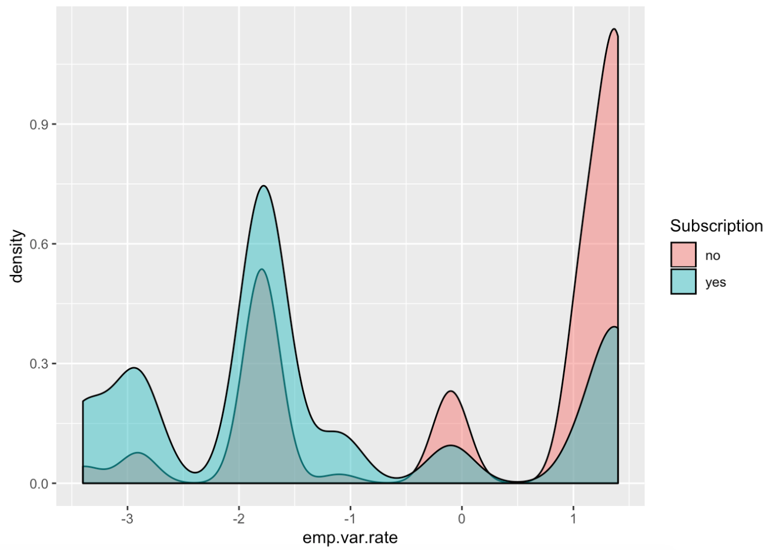

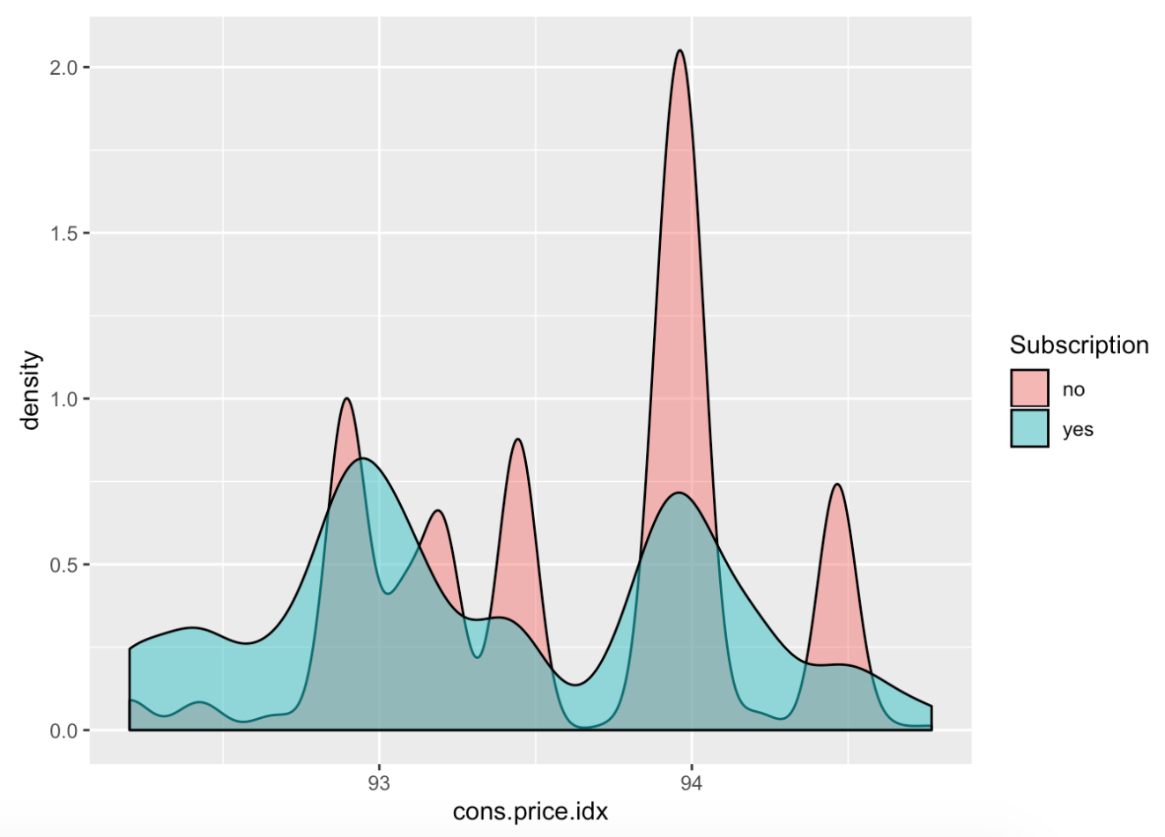

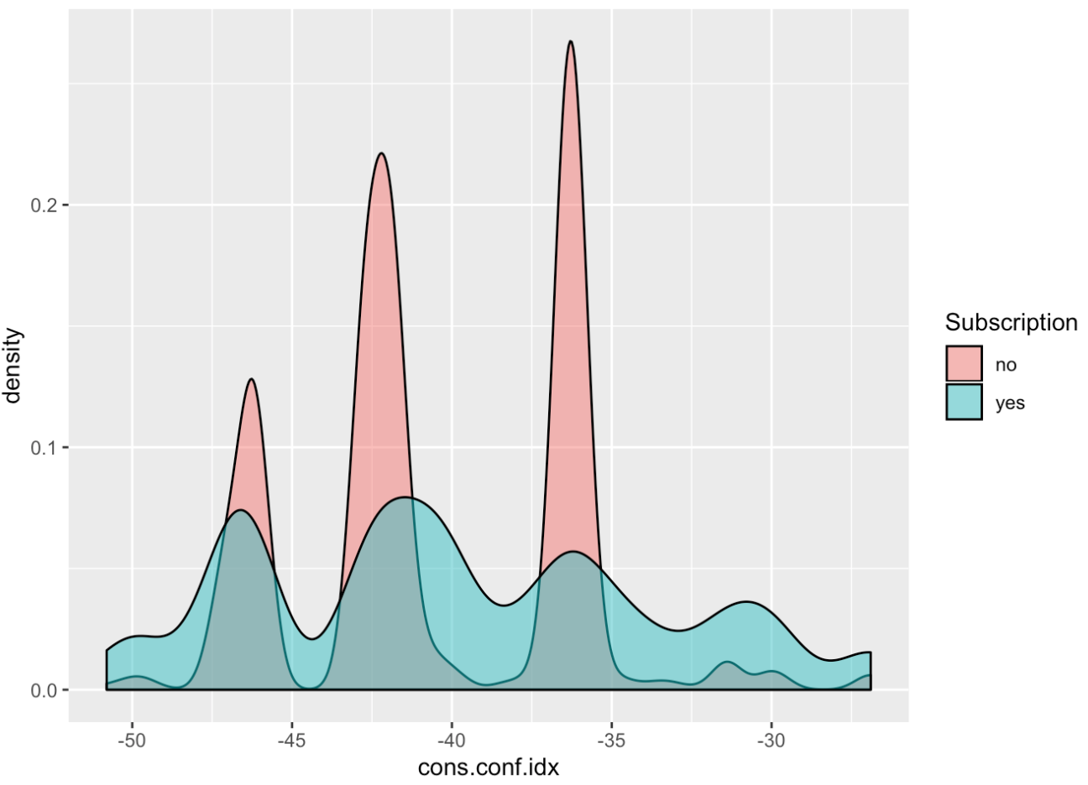

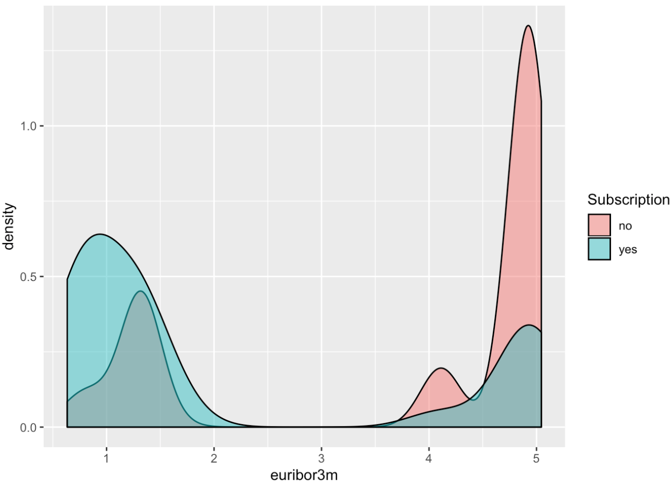

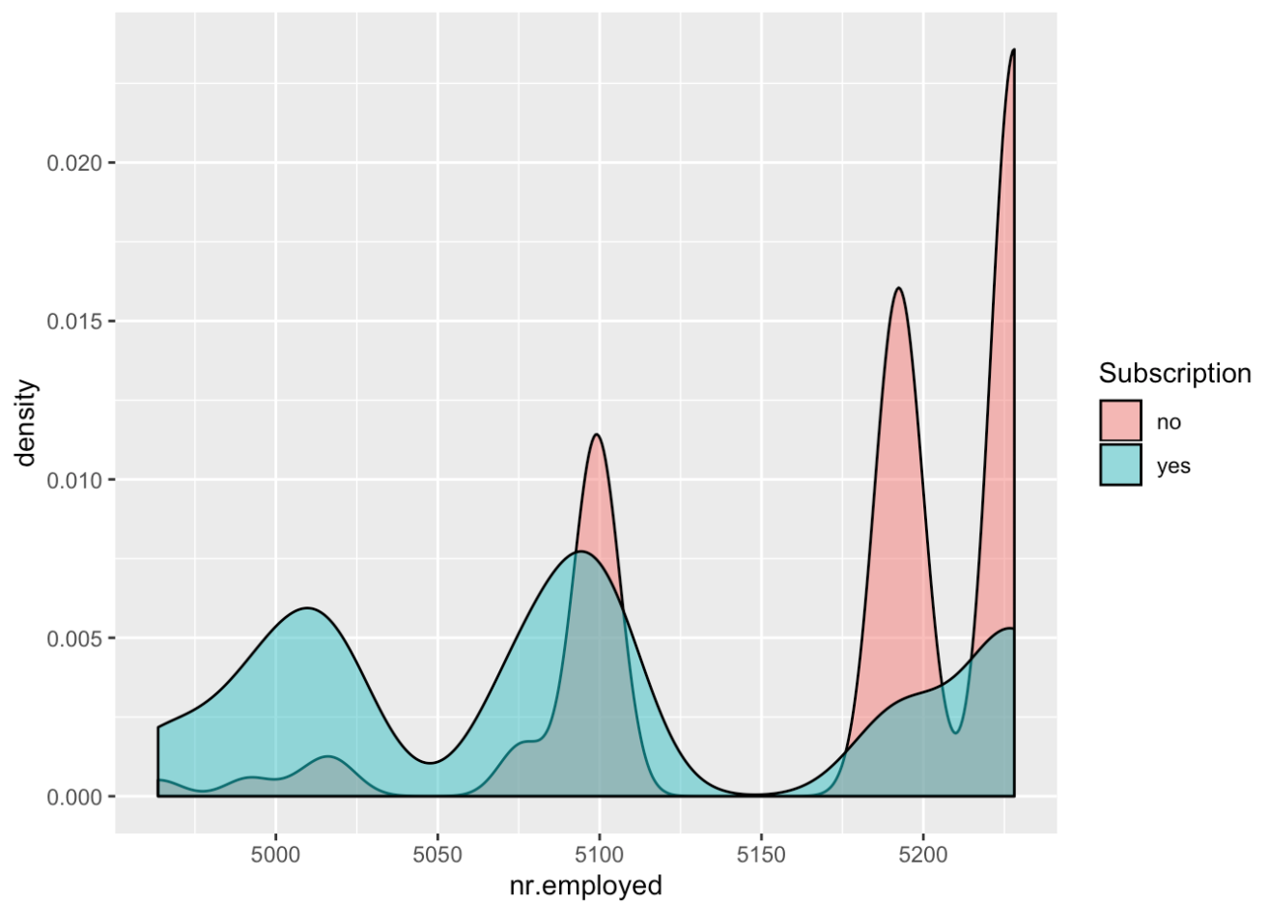

## Figure 16

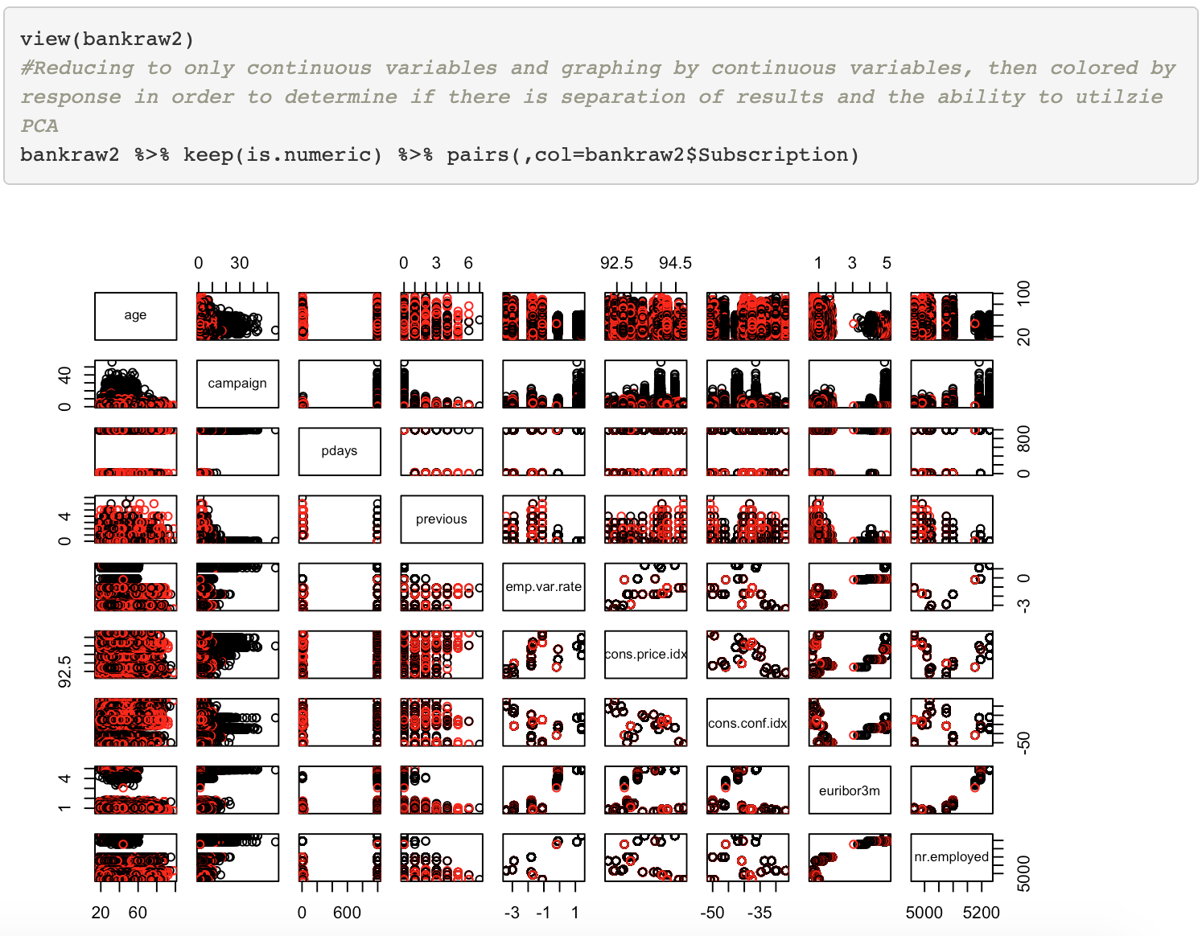

## Figure 17

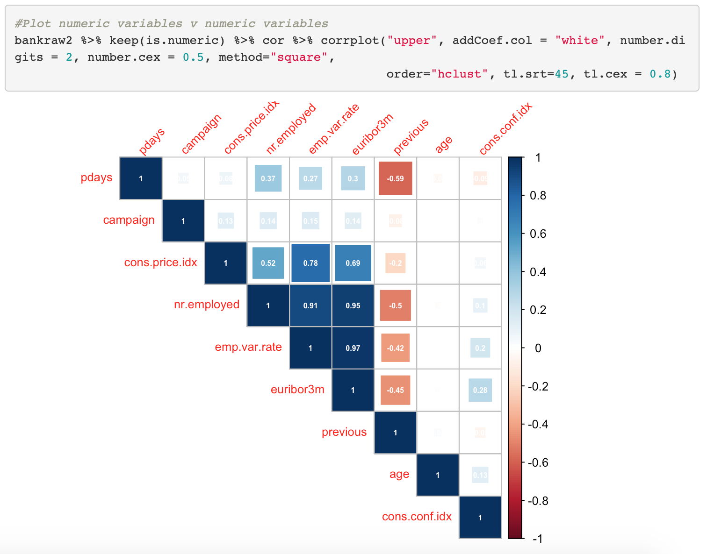

## Figure 18

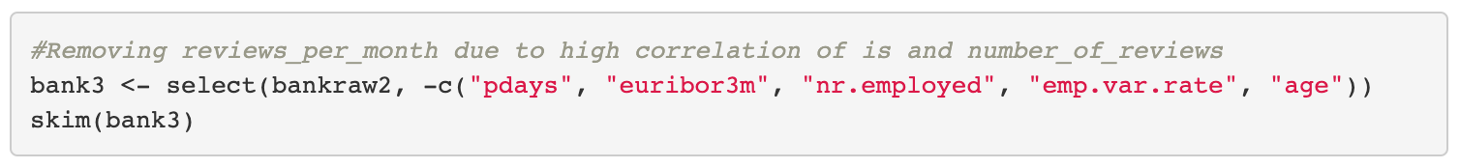

## Figure 19

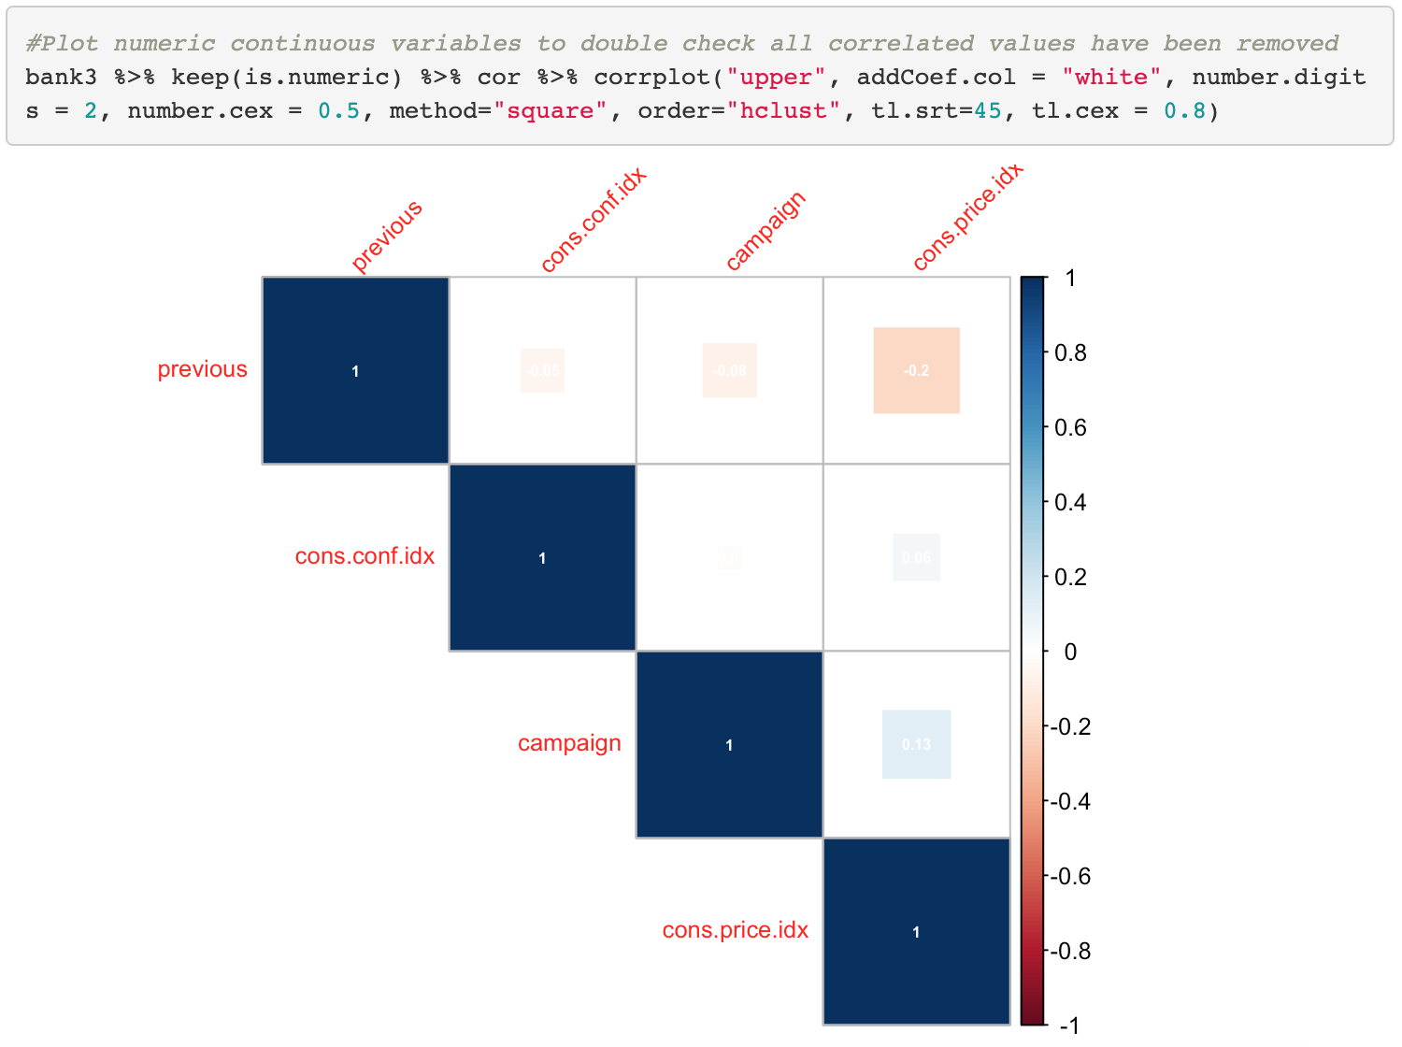

## Figure 20

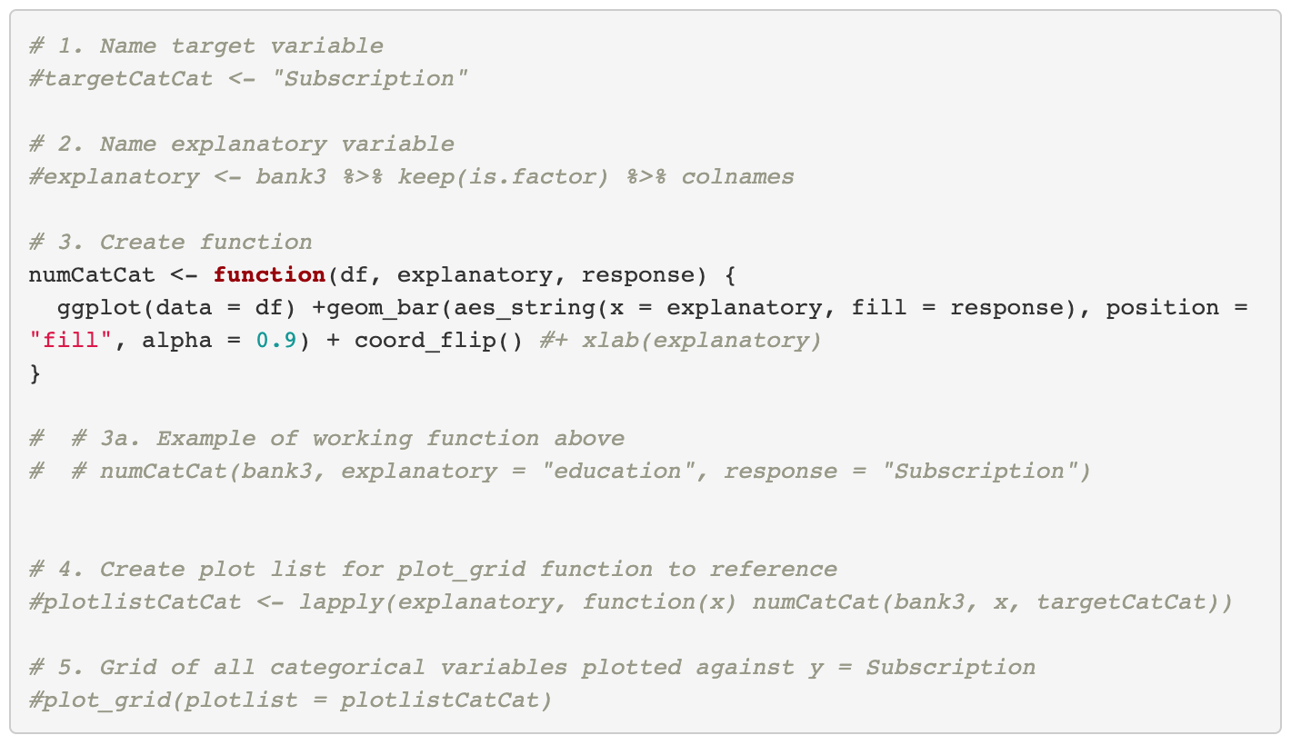

## Figure 21

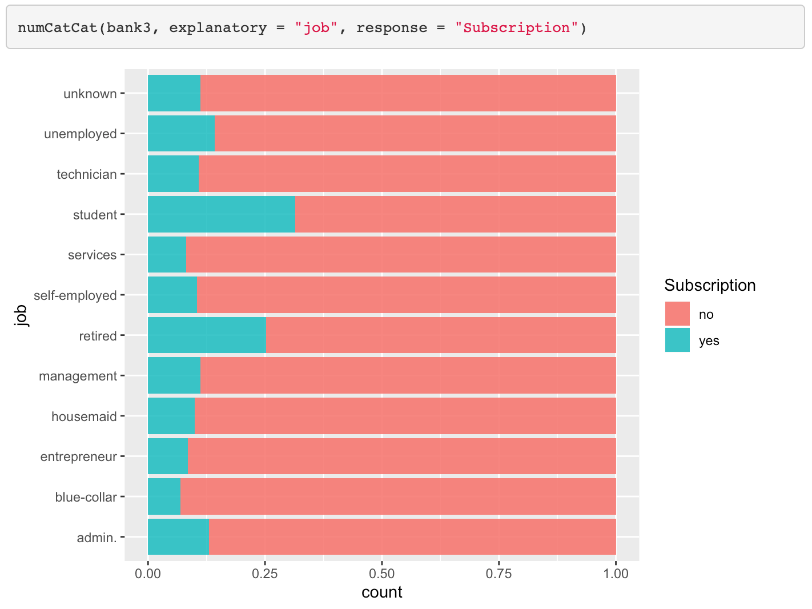

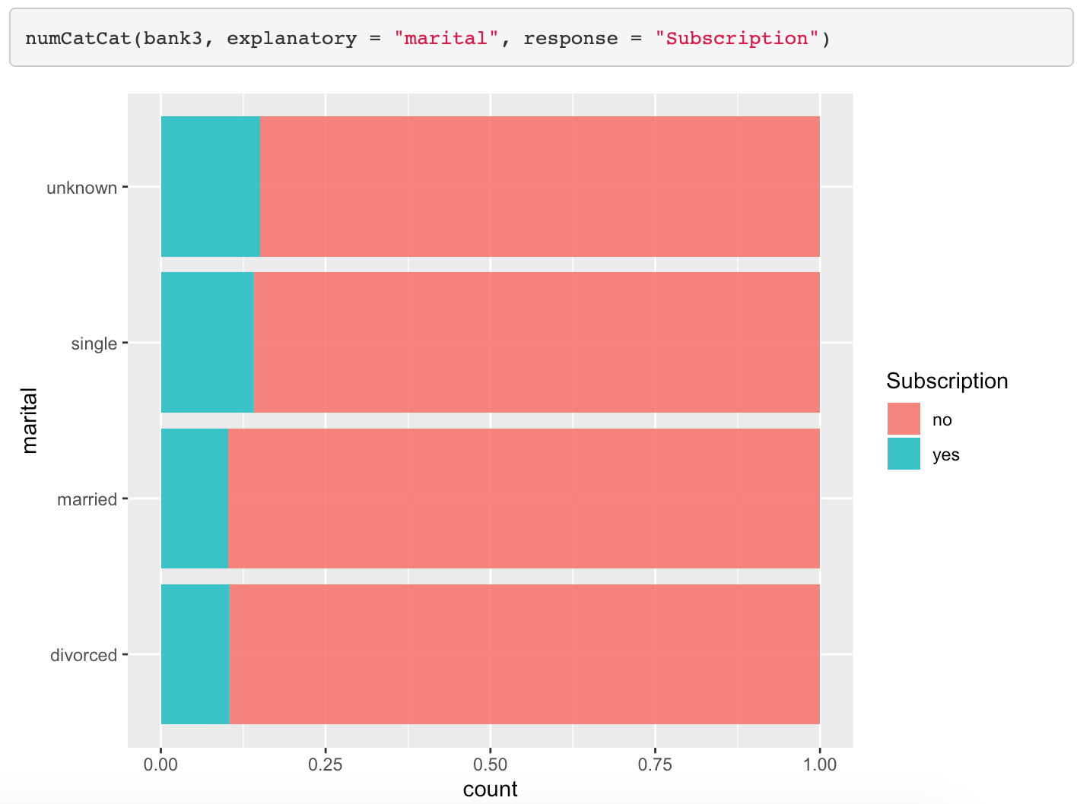

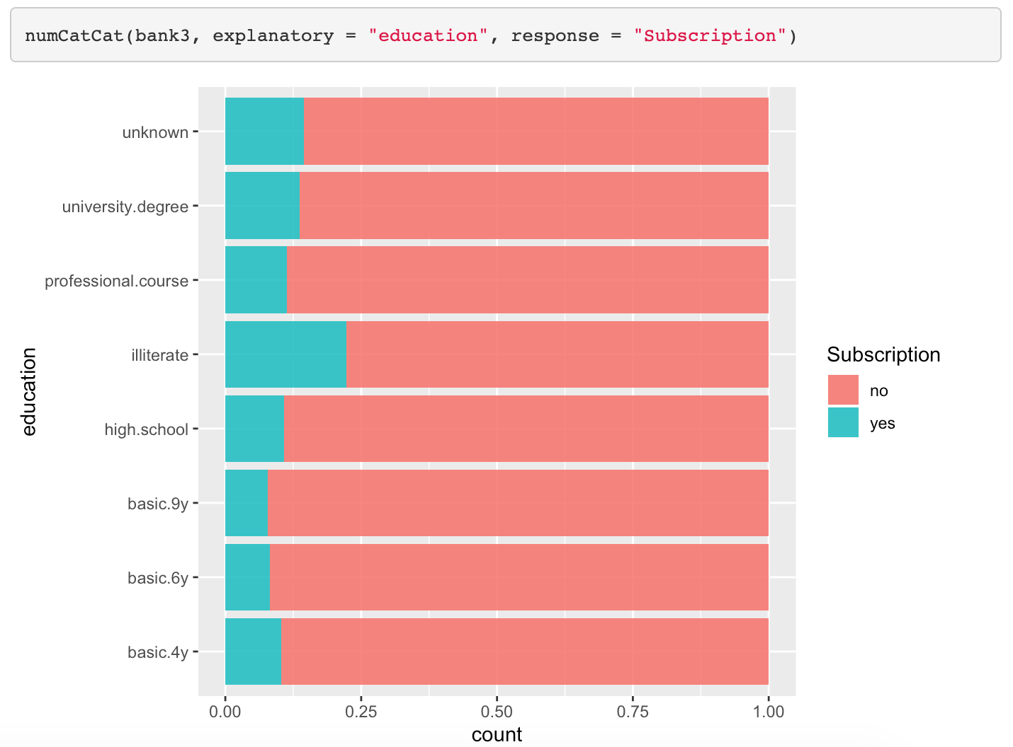

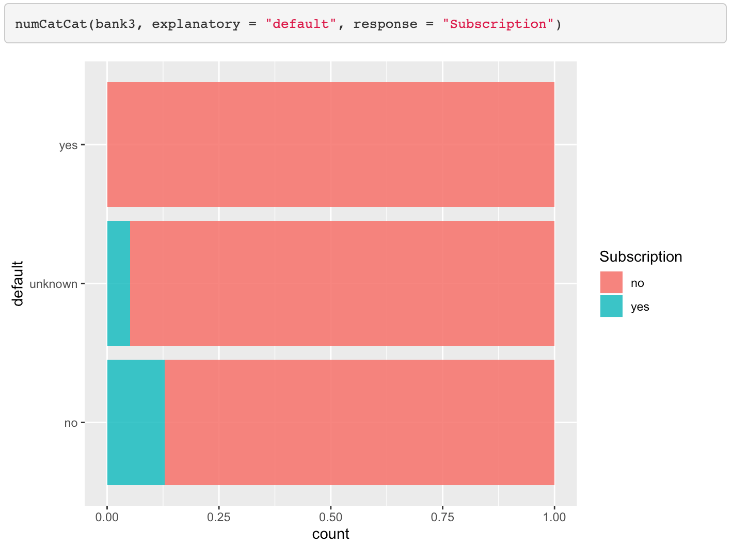

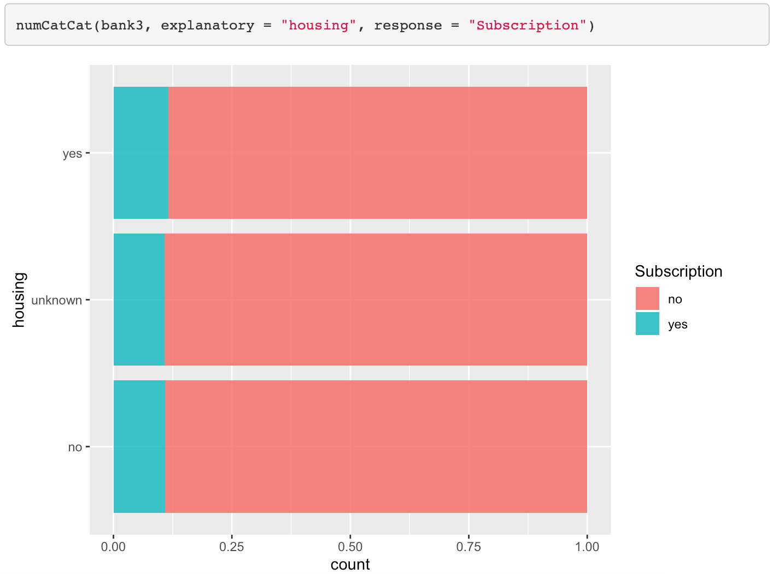

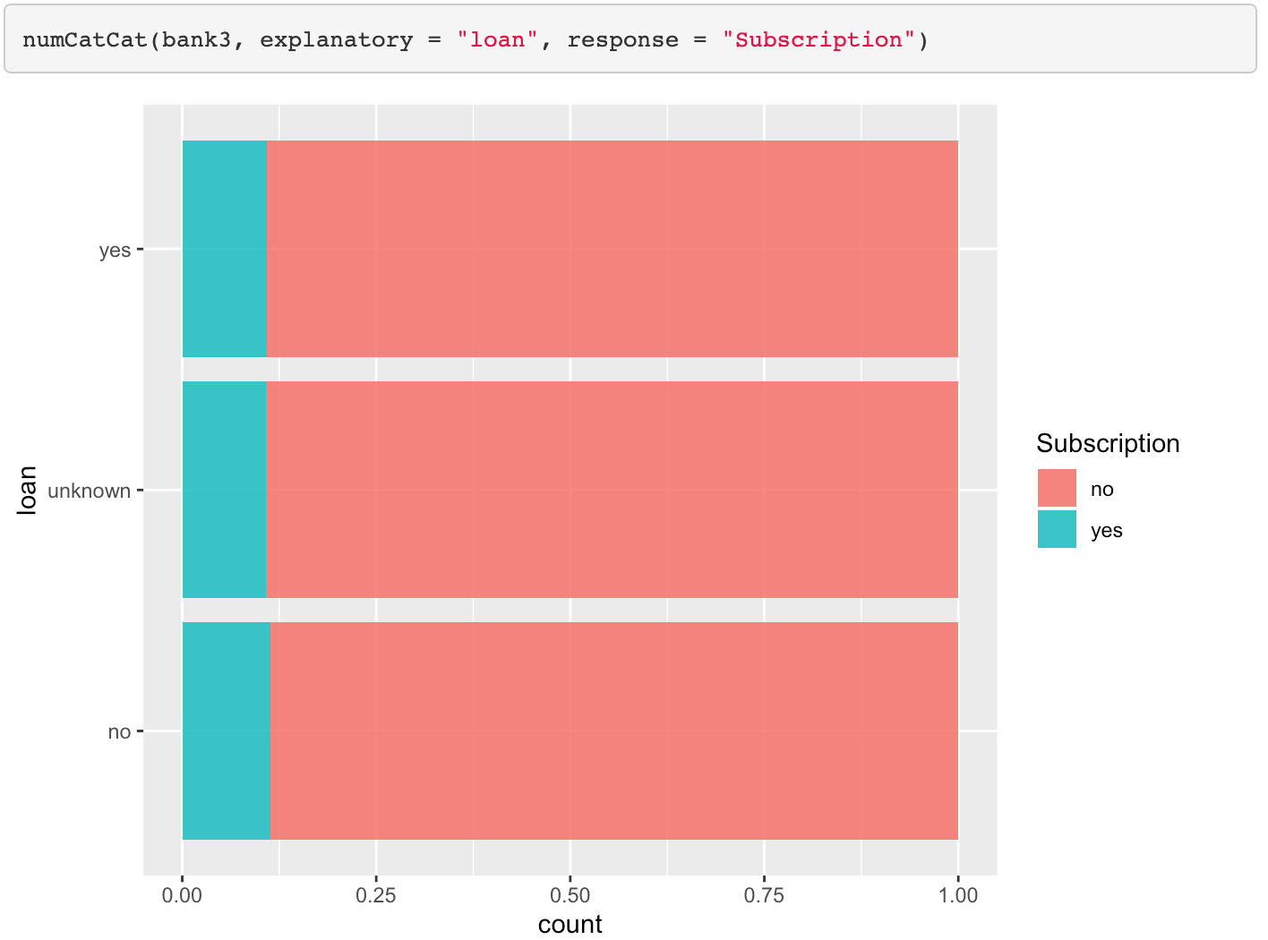

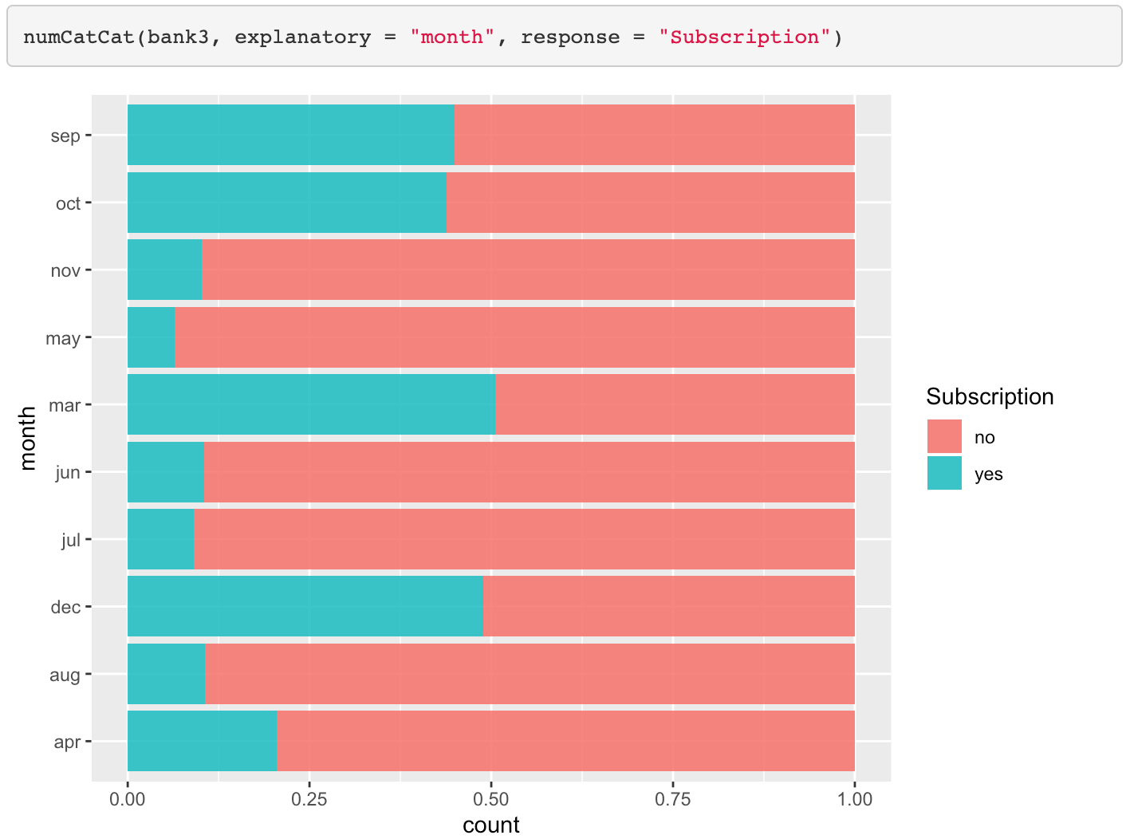

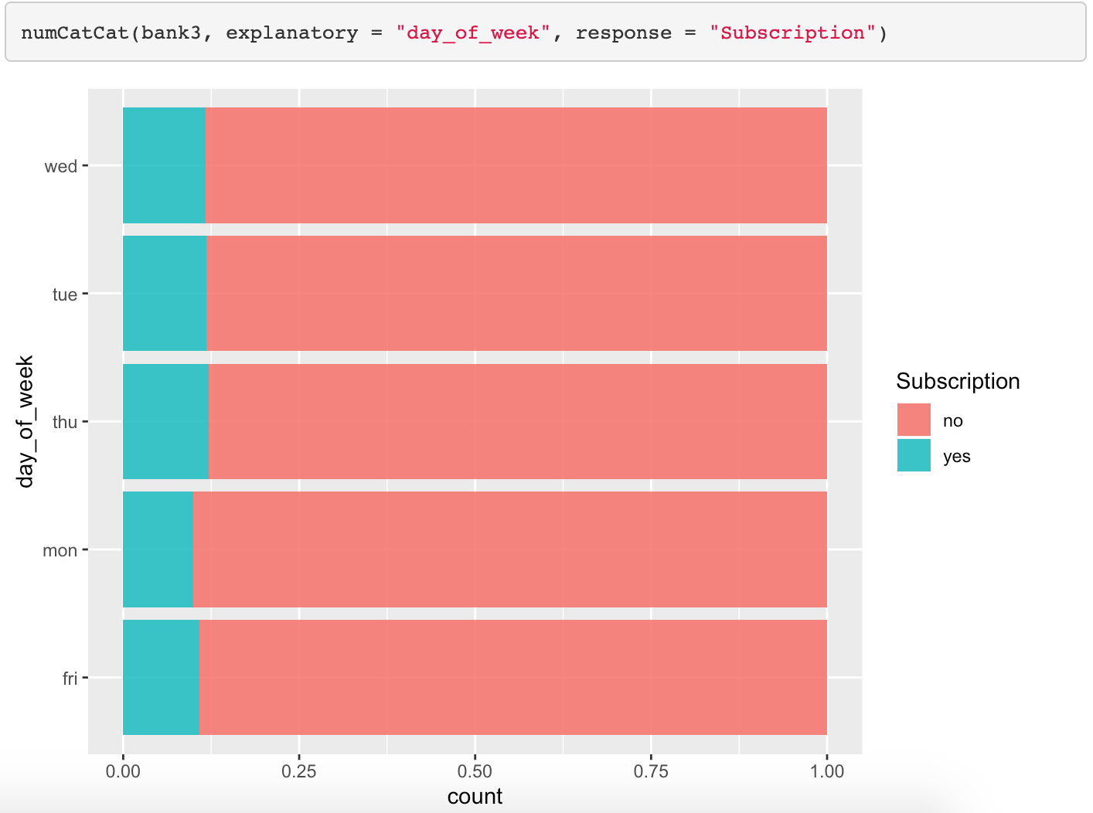

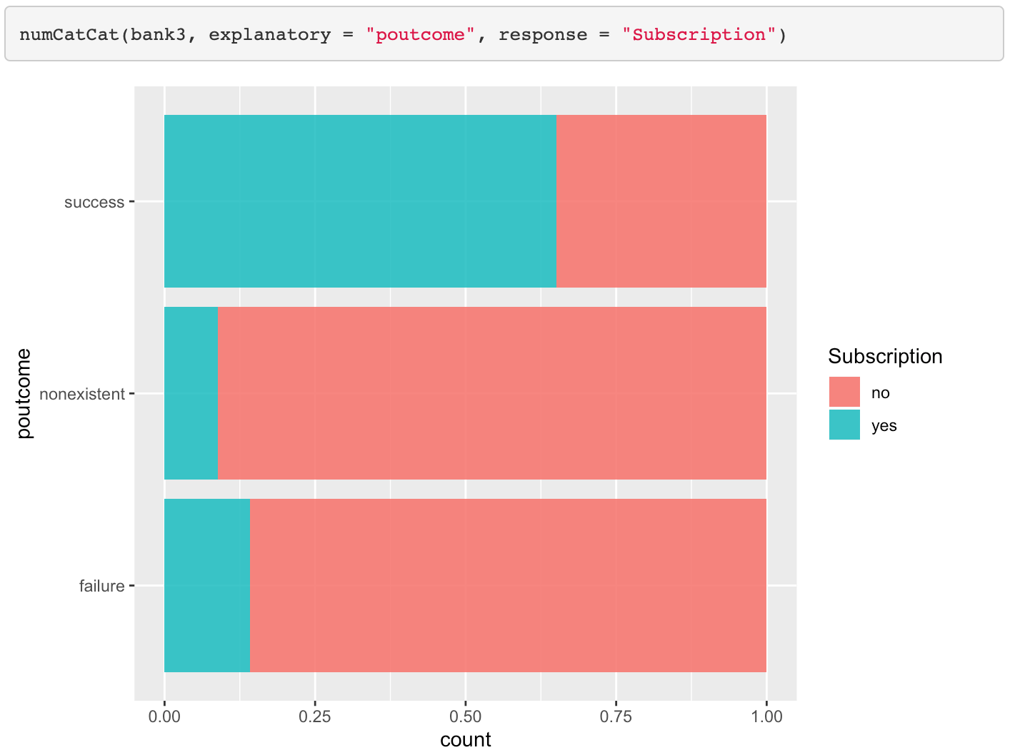

## Figure 22



## Figure 23

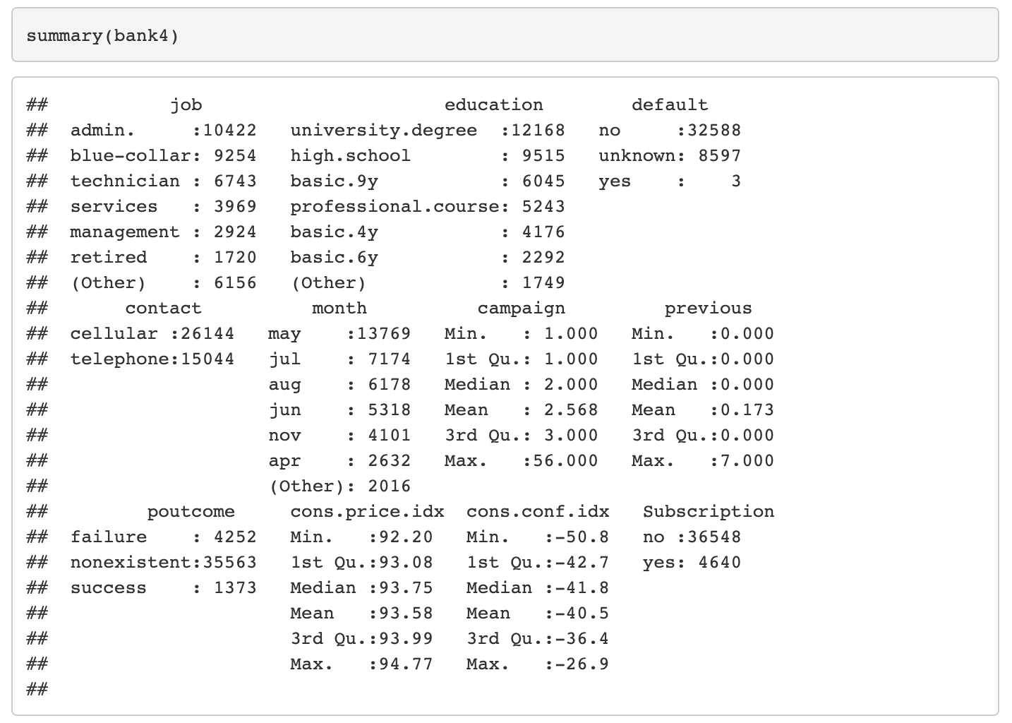

## Figure 24

**proc** **logistic** data=banktrain plots=ROC;

class Subscription job education default contact month poutcome / param=ref;

model Subscription(event='yes') = job default education contact month campaign previous poutcome euribor3m cons_price_idx cons_conf_idx / scale=none aggregate lackfit ctable outroc=trainroc;

output out=trainpreds;

score data=banktest out=testpreds outroc=testroc fitstat;

**run**;

#### 

## Figure 25

**proc** **logistic** data=banktrain plots=ROC;

class Subscription job default contact month poutcome / param=ref;

model Subscription(event='yes') = job default contact month campaign poutcome euribor3m cons_price_idx cons_conf_idx / scale=none aggregate lackfit ctable outroc=trainroc;

output out=trainpreds;

score data=banktest out=testpreds outroc=testroc fitstat;

**run**;

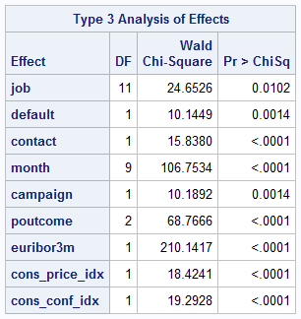

## Figure 26

**proc** **logistic** data=banktrain_raw plots=ROC;

class Subscription contact default month poutcome / param=ref;

model Subscription(event='ye') = contact campaign default month poutcome cons_price_idx cons_conf_idx euribor3m / scale=none aggregate lackfit outroc=rtrainroc;

output out=rtrainpreds;

score data=banktest_raw out=rtestpreds outroc=rtestroc fitstat;

**run**;

**proc** **freq** data=rtestpreds;

tables I_Subscription*Subscription;

**run**;

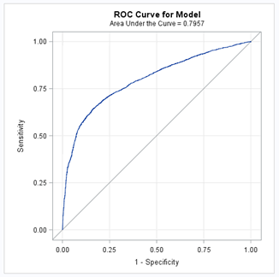

## Figure 27

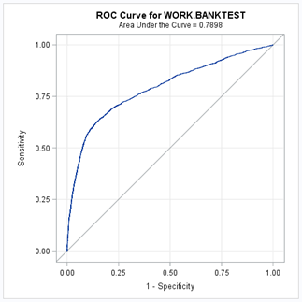

## Figure 28



## Figure 29

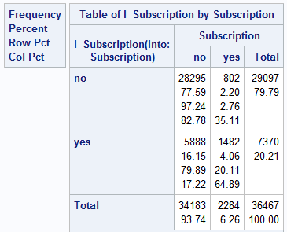

## Figure 30

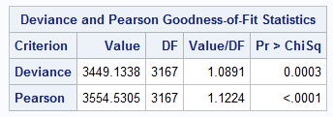

## Figure 31

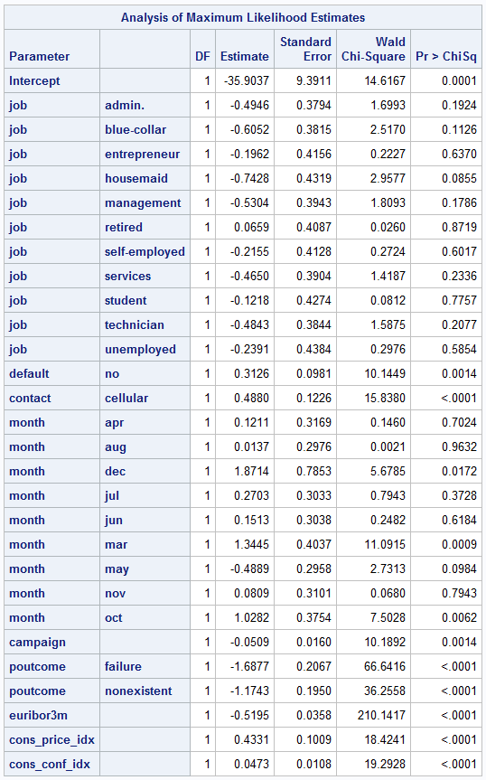

## Figure 32

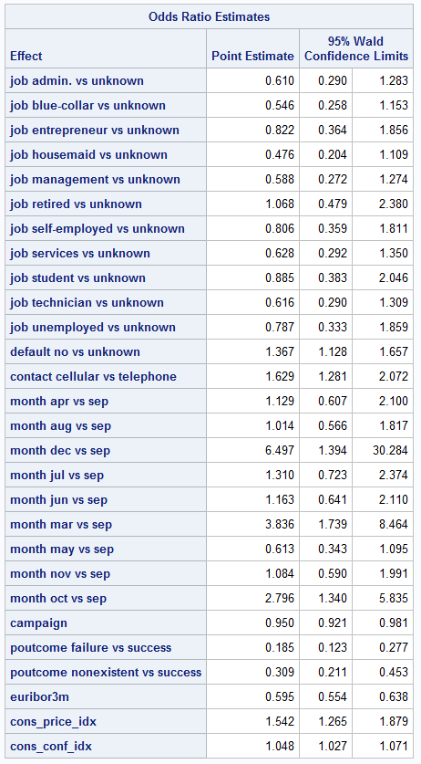

## Figure 33

## Figure 34

## Figure 35

## Figure 36

## Figure 37

## Figure 38

## Figure 39

## Figure 40